WE ALL SCREAM FOR ICE CREAM! BUT WHICH ONE? | 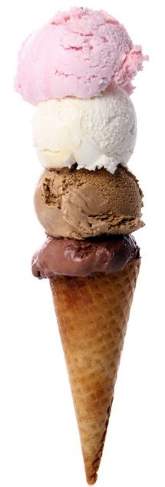
Nothing is more satisfying on a hot summer day than a creamy frozen treat. When considering your options, you may opt for frozen yogurt believing that it’s a healthier choice. But is it really better for you than ice cream?

The ingredients of a brand and flavor of frozen yogurt largely determine whether it’s actually healthier. Ice cream and frozen yogurt both contain two main ingredients: dairy and sugar. They also contain flavouring and add-ins. Frozen yogurt incorporates cultured milk or yogurt, and the fat content of the milk largely determines how much fat is in the final product. Ice cream, on the other hand, uses cream as a base.

It’s important to note that some frozen yogurts may contain just as much added sugar as ice cream – or more! – to compensate for the yogurt’s naturally tangy flavour.

Healthy Tip!
Add a kick and some health benefits to your store-bought frozen yogurt or ice cream. Complete your scoop with one of these tasty toppings.

Nuts add protein and healthy fats  Unsweetened coconut gives you extra fibre  Dark chocolate offers antioxidants | Berries include lots of vitamins and antioxidants  Low-fat granola adds fibre and a satisfying crunch  (watch the sugar content - better yet, make your own)

Why not make your own frozen treat?! It’s easier than you think and with fewer ingredients than store-bought versions, you know it’s a healthier option. Check out the recipe below.

STRAWBERRY FROZEN YOGURT
Makes 4 servings
.
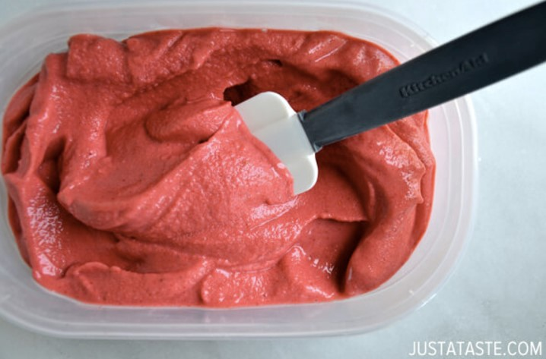 | 4 cups frozen strawberries  3 tbsp agave nectar or honey  1/2 cup plain yogurt  1 tbsp fresh lemon juice  Add all ingredients to a food processor and blend until creamy (about 5 minutes). Serve frozen yogurt immediately or transfer to an airtight container and store in the freezer for up to 1 month.  Nutritional Information per Serving (1 cup): Cal 100 | Fat 0g | Fibre 3g | Sugar 20g

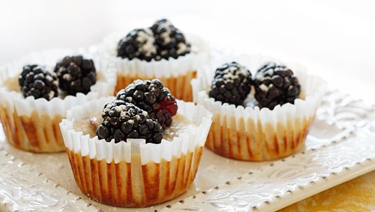 |  | 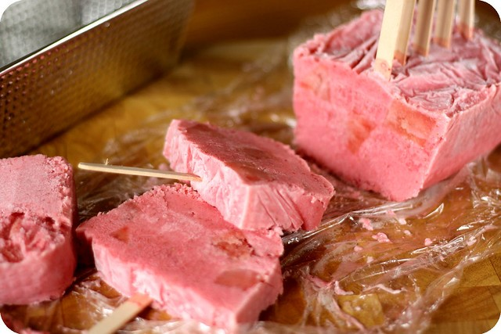
Lemon Cheesecake Yogurt Cupcakes |  | Strawberry Watermelon Yogurt Ice Pops
Makes 12 servings |  | Makes 8-10 servings
12 reduced-fat vanilla wafers  8 oz reduced-fat cream cheese, softened  1/4 cup sugar  1 tsp vanilla  6 oz reduced-fat vanilla Greek yogurt  2 large egg whites  3 tbsp lemon juice  1 tbsp lemon zest  1 tbsp all-purpose flour  24 blackberries |  | 2 cups vanilla yogurt (not fat-free – see note)  2 cups fresh or frozen strawberries, sliced  Juice and zest of 1 lime  20 cubes of watermelon, 1/2-inch each  8 to 10 wooden popsicle sticks
Line a loaf pan with plastic wrap and set aside.

In a blender, combine yogurt, strawberries, lime juice, and zest. Puree until well combined.

Pour the mixture into the prepared pan. Drop in the watermelon cubes making sure they are evenly distributed.
Heat oven to 350 degrees.  Prepare a 12-cupcake pan with liners. Place a vanilla wafer in each liner.  Add cream cheese, sugar, and vanilla to a bowl and mix with an electric mixer. Gradually add in yogurt, egg whites, lemon juice and zest, and flour. Do not over mix.  Pour mixture into liners filling each halfway. Bake for 25 minutes or until centers are almost set.  Cool cupcakes to room temperature then chill in the fridge for 2-3 hours. Top with fresh berries before serving.  Cal 109 | Fat 4.7g | Carb 12.6g | Protein 3.6g | Fibre 1.1g | Sodium 107.9mg |  | Cover the pan with plastic wrap, making sure the plastic touches the top of the yogurt mixture. This will prevent a skin from forming.  With the tip of a sharp knife, make small cuts in the plastic at even intervals. Each section will be a popsicle. Insert a wooden popsicle stick into each cut.  Freeze for 6 hours or until pops are completely frozen.  Remove the pan from the freezer and run warm water over the side of the pan to loosen the edges of the ice pops. Remove the plastic and lift the frozen loaf out of the pan. With a sharp knife, cut between each popsicle stick to form the pops.  Note: If using yogurt with low-fat content, popsicles will have an icy consistency and break easily.  Cal 76 | Fat 0.6g | Carb 15.6g | Protein 2.7g | Fibre 0.6g | Sodium 32.3mg
Sources skinnytaste.com/2011/05/lemon-cheesecake-yogurt-cups.html#more
andthenidothedishes.blogspot.com/2010/07/strawberry-watermelon-yogurt-ice-pops.html
calorieking.com | livestrong.com | heart.org | eatwisconsincheese.com
Images by freepik

