Holiday stress sets in when you try to do it all. Ann Vernon, a counseling professor at the University of Northern Iowa, defines stress as an emotional reaction to circumstances when you feel out of control. Take steps to prevent the stress and depression that can often come with the holidays. Learn to recognize your holiday triggers, such as financial pressures or personal demands, so you can combat them before they lead to more challenges. With a little planning and some positive thinking, you can find peace and joy during the holidays. |  | 
5 SIGNS YOU NEED TO BUST SOME HOLIDAY STRESS
1 | You’re irritable.
2 | You’re losing sleep.
3 | You’re losing or gaining weight.
4 | You feel tense and have muscle aches or headaches.
5 | You feel overwhelmed.

STRESS AND WEIGHT GAIN  Levels of "the stress hormone," cortisol, rise during times of physical or psychological stress. This can cause fluctuations with appetite and insulin levels. Energy and blood sugar levels may lower, causing you to crave sugary, fatty foods. Ideally, this doesn’t become a habit. |  | The disruption of cortisol secretion may promote weight gain, and also affect where you put on weight. Studies have shown that stress and elevated cortisol levels tend to cause fat deposition in the abdominal area. Also referred to as “toxic fat”, abdominal fat deposition is strongly correlated with the development of cardiovascular disease including heart attacks and strokes.

TIPS TO BEAT HOLIDAY STRESS
Take a Breather.  - Make time for yourself. Spending just 15 minutes alone without distractions may be all you need to refresh your mind and body.  - Take a walk, listen to soothing music, and find something that reduces stress by clearing your mind and slowing your breathing.  - Look for alternatives around the stressor. Be realistic and tell yourself, “If I have time, I’ll do this. If not, I’ll only do that.” |  | 
 | Don’t abandon healthy habits.  - Don't let the holidays become a free-for-all. It only adds stress and guilt.  - Have a healthy snack before big feasts.  - Continue to get plenty of sleep and don’t forget to move as much as you can!
Stick to a budget.  - Before you go gift and food shopping, decide how much you can afford to spend and stick to it.  - Don’t try to buy happiness with an overload of gifts. Donate to a charity in someone's name, give homemade gifts, or start a family gift exchange. |  | 
 | Plan ahead.  - Set specific days for shopping, baking, and other activities.  - Plan menus and make shopping lists to prevent last-minute trips to the store.  - If you need time to work around the house, ask a family member to take the kids out.  - If your schedule is full, delegate family members to help you out. For example, assign each person a room to clean.
Don’t give in to the “gimmies”.  - Giving in to every “I want!” can cause financial distress.  - It’s okay to tell your child that a gift is too expensive. Even Santa Claus has limits.  - Focus on holiday traditions that don’t cost extra. Bake cookies, go caroling, or enjoy skating as a family.  - Give to families in need or volunteer. Incorporate the spirit of giving by asking children to pick an old toy to donate. |  | 
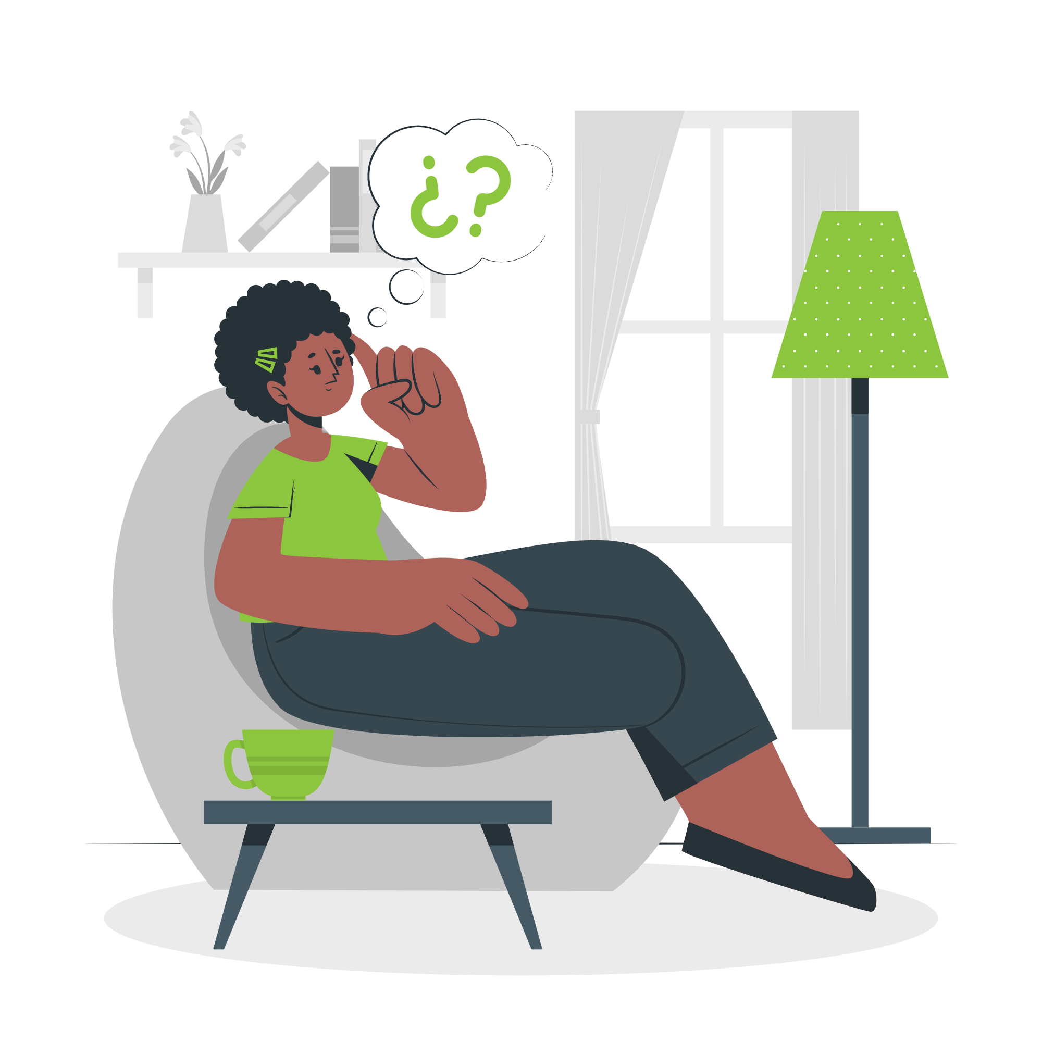 | Learn to say no.  - Saying yes when you should say no can leave you feeling resentful and overwhelmed.  - Friends will understand if you can't participate in every project or activity.  - If you must attend an event, try to eliminate something from your agenda to balance time so you’re not mentally exhausted.
Be realistic about relatives.  - When the in-laws visit, have realistic expectations for the short term.  - Don’t try to solve past issues with family members over the holidays. Use discretion and remember, there’s no need to bring up every little irritation.  - If going to a certain relative’s house every year causes a lot of holiday stress, try changing the location or visit every other year. |  | 

Sources: fun.familyeducation.com | www.medicinenet.com | www.mayoclinic.com | Images by Freepik.com

