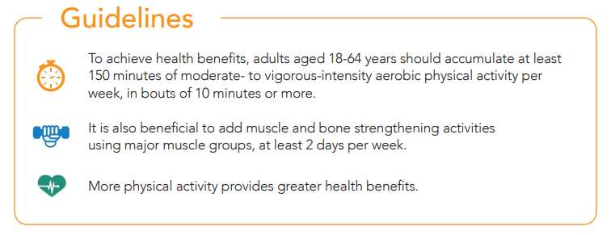

|  |
| --- |
| **10 TIPS TO STAY ACTIVE THIS HOLIDAY SEASON** |

|  |  |  |  |
| --- | --- | --- | --- |
|  |  |  |  |

|  |  |  |
| --- | --- | --- |
| ➀ | **Take time for yourself.**  Set aside at least 30 minutes each day to relax and get some exercise. When you're feeling "peopled-out," do something by yourself. This is one guarantee of some time alone during the chaotic holidays. | |
|  |  |  |
| ➁ | **Stick to your existing routine.**  You’ve done great at keeping to your routine, so why stop now? Write the days you’ll exercise in your calendar or set a reminder in your phone. Bring a family member along since the holiday season is a time of sharing! | |
|  |  |  |
| ➂ | **Keep a record of daily fitness activities.**  After your workout, walk, or any activity, write down what you did and for long. This will help you see if you need to add more active minutes to your day, or when it’s time to reward yourself for keeping up with your goals. | |

|  |  |  |  |  |  |
| --- | --- | --- | --- | --- | --- |
| ➃ | **Make New Year’s Resolutions early this year.**  Start working toward your wellness goals by December 1. Write them on sticky notes or create a vision board and post them where you'll see them often. Seeing them throughout the day will remind you of what you want to achieve and help keep you motivated. | | | | |
|  |  | | | |  |
| ➄ | **Do your Christmas shopping.**  When you shop for those last minute gifts, fit in lots of walking. Park as far away from shop entrances as you can and briskly walk to your destination. If you travel by bus or metro, get off a few stops earlier and walk the rest of the way. | | | | |
|  |  | | | |  |
| ➅ | **Shovel the driveway.**  Clearing a driveway full of the white stuff is a great way to get some exercise in. It can also give you some quiet time to clear your head and enjoy the winter scenery. | | | | |
|  |  | | | |  |
|  | |  |  |  | |
|  |  | | | |  |
| ➆ | **Commit to a brisk walk.**  Before or after dinner, no matter where you eat, commit to a brief 10 to 15-minute, *brisk* walk. Enjoy the holiday lights, visit the nativity scene at a local school or church, or walk with the family to visit a friend or relative. | | | | |
|  |  | | | |  |
| ➇ | **Buy a pedometer or track on your phone.**  Treat yourself to activity! Use a pedometer to track how many steps you take in a day and make a commitment to increase that number. Your goal may be 6,000 - 10,000 steps each day, but starting anywhere and increasing some steps each day is most important! | | | | |
|  |  | | | |  |
| ➈ | **Get outside!**  Getting enough Vitamin N (Nature) is so helpful for our mental wellness. Go sledding, cross-country skiing, or skating. Many winter activities are inexpensive and great exercise – and a lot of fun! | | | | |
|  |  | | | |  |
| ➉ | **Make it a family affair.**  Instead of sitting on the coach to watch another holiday movie, try doing something different this holiday season. Play a ball game in the yard, make a gingerbread house, play board games or charades, or sing carols. If you have snow, have a snowball fight or build a snow fort. | | | | |

|  |
| --- |
| “Exercise is the key not only to physical health, but to peace of mind.”  Nelson Mandela |

Sources: www.phac-aspc.gc.ca | www.reslife.net/ | www.canadianliving.com/ | http://www.healthcentral.com/

csep.ca/CMFiles/Guidelines/CSEP_PAGuidelines_0-65plus_en.pdf | Images by Freepik.com