DID YOU KNOW? | 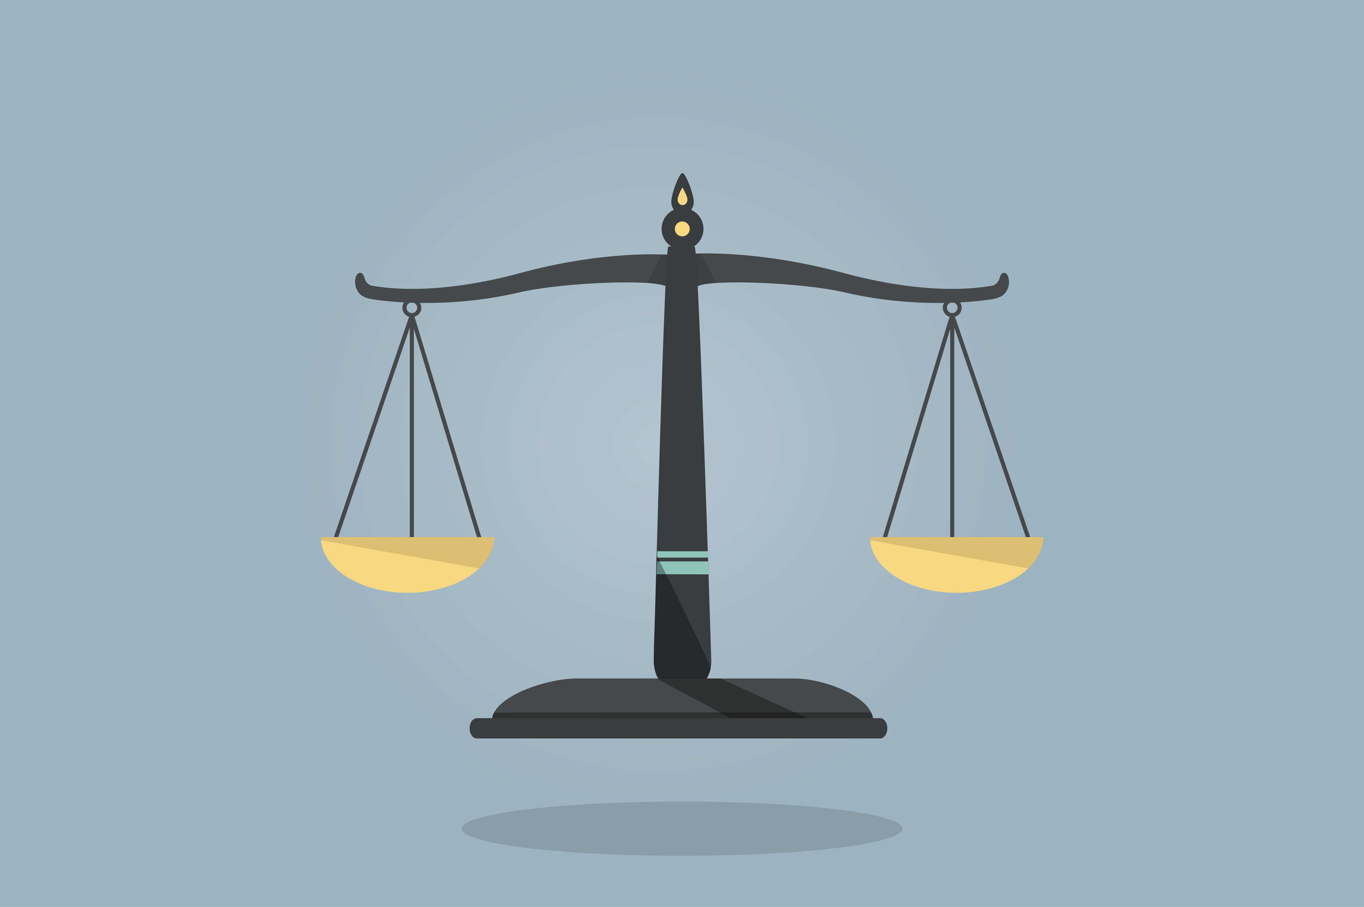
Almost all of the weight that people gain over the course of a year can be explained by the pounds they add over the holiday period.

Maintaining weight is all about balance. If you take in more calories than you burn, you may store the extra energy as fat and gain weight. To maintain your weight, you need to balance the energy you take in with the energy you burn.

6 TIPS TO MAINTAIN A HEALTHY WEIGHT

One |  | Focus on friends and family instead of food.  Remember, the holidays are a time to slow down and catch up with loved ones. Share stories, play games, have Zoom chats and spend time outdoors enjoying the winter weather together. Family gatherings often center around the dinner table, but we can focus on so many other things to celebrate family.
Stay active.  The holidays are busy, but you can still make time each day for exercise. Go skating or play games in the backyard. After eating a holiday dinner, bundle up and go for a walk. Clean up the leftover food after a meal to help avoid snacking and get moving around! |  |  | 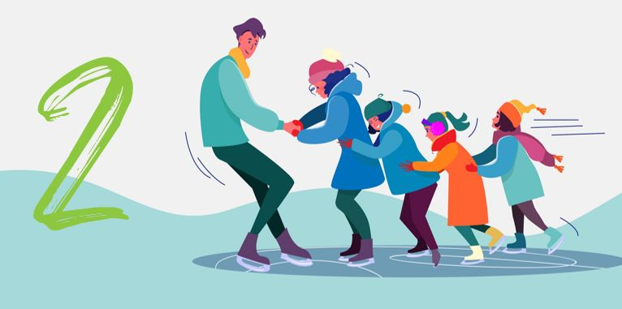
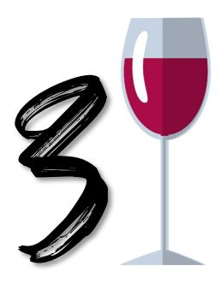 | Be mindful of holiday drinking.  If you drink alcohol, remember to eat something beforehand. Whether it’s a glass of eggnog or red wine, holiday drinks can add a significant number of calories.

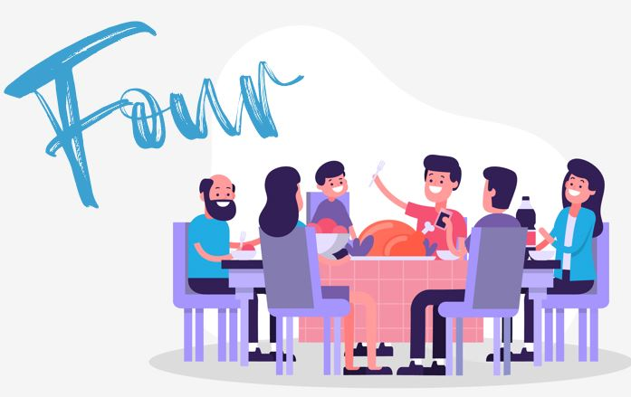 |  | Eat a healthy snack before a large meal.  Don’t skip meals or snacks earlier in the day to “save” calories and carbs for the large holiday feast later on. If you skip meals, it will be harder to keep your energy levels in control. Also, if you are overly hungry, you will be more likely to overeat. Snack on healthy foods with lots of protein. These keep you feeling full for a longer period of time.
5 | Control your portions.  - Eat slowly and really enjoy the foods that you may only have during the holidays. If you plan to have dessert, cut back on another food during the main course.  - Use smaller plates. When you serve yourself using the smaller plate, you will be consuming 20% less, but still feel like you ate an entire plate of food.  - Use a tall, skinny glass instead of a short, wide one. If you pour less, you drink less!
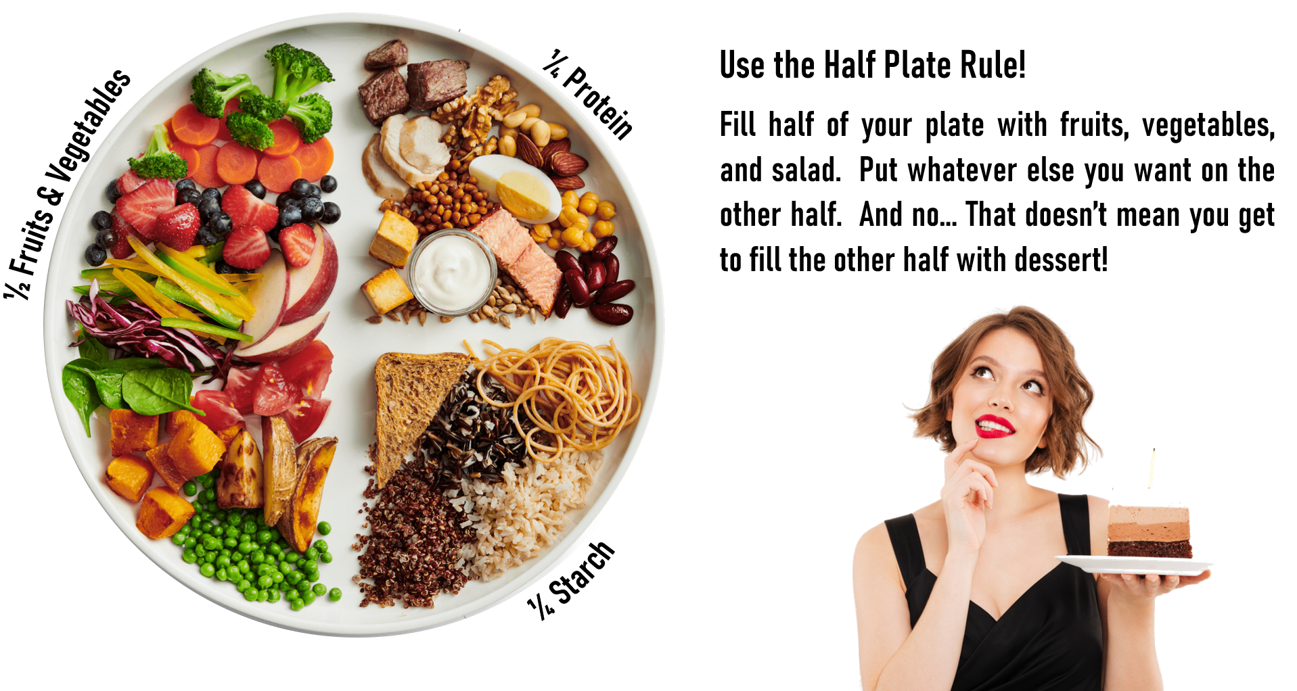
If you overindulge, get back on track.  If you eat more food than you planned or had one too many slices of cake, don’t think you have failed. Include extra exercise, monitor your energy levels, drink lots of water and get back on track with your usual eating habits the next day. |  |  |  | Six

Sources: www.nih.gov | www.foodinsight.org | Images by Freepik.com

