**REVAMP HOLIDAY FAVOURITES**

Healthy holiday eating doesn’t mean you can’t prepare a flavourful feast. You simply need to look for ways to reduce fat and calories. Incorporate the following tips into your holiday cooking to make some of your favourite dishes a little healthier.

|  |  |  |
| --- | --- | --- |
| **Gravy**  Refrigerate the gravy to harden the fat, then skim it off. This will save a whopping 56 grams of fat per cup! | **Stuffing**  Use a little less bread and include more vegetables. Add fruit such as cranberries or apples. Flavour with low-sodium chicken or vegetable broth or applesauce. | **Turkey**  Enjoy delicious, roasted turkey breast without the skin and save 11 grams of saturated fat per 3-ounce serving. |
| **Green Bean Casserole**  Cook fresh beans with chunks of potatoes instead of cream soup. Swap the fried onion rings on top with almonds for a healthier crunch. | **Mashed Potatoes**  Use skim milk and chicken broth rather than whole milk and butter. Add flavour with parmesan cheese and garlic, and keep the skins on. | **Desserts**  Substitute 2 egg whites for each whole egg in baked recipes. Replace heavy cream with evaporated skim milk in cheesecakes and cream pies. Top cakes with fresh fruit, fruit sauce, or a sprinkle of powdered sugar instead of frosting. |

**TRY SOMETHING NEW!** Create some new favourites with these tasty holiday dishes.

|  |  |  |  |  |
| --- | --- | --- | --- | --- |
| **Pork, White Bean & Kale Soup** | |  | **Pomegranate Poached Pears** | |
|  | This hearty soup is perfect for a chilly night. Packed with protein and vitamins, you don’t have to feel guilty about enjoying a second helping! |  | This super simple, low-fat dessert makes a striking finale to a festive meal. Poaching gives the dish lots of flavour without the need for oils or butter, and there’s no need for added sugar. |  |

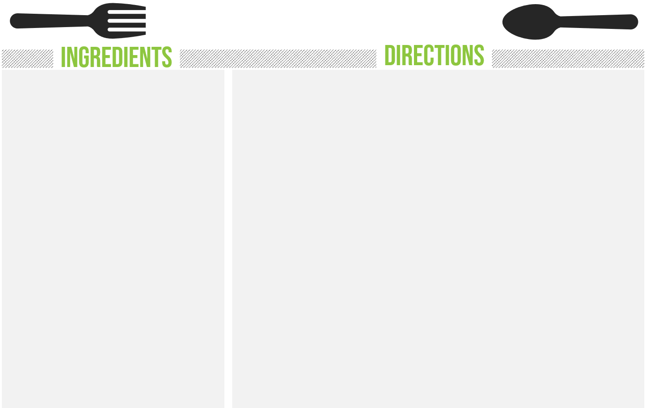

Nutrition Info Per Serving (1 2/3 cup): Cal 262 | Fat 6g | Sat Fat 2g | Carb 26g | Protein 25g | Fiber 7g | Sodium 300mg

1. Heat oil in a pot over medium-high heat. Add pork, sprinkle with salt, and cook, stirring once or twice, until no longer pink (2 minutes). Transfer to plate, leaving juices in the pot.
2. Add onion to the pot and cook, stirring often, until just beginning to brown (2-3 minutes). Add garlic, paprika and crushed red pepper, and cook, stirring constantly, until fragrant, (30 seconds). Add wine and tomatoes, increase heat to high, and stir to scrape up any browned bits. Add broth and bring to a boil.
3. Add kale and stir just until it wilts. Reduce heat to a lively simmer and cook, stirring occasionally, until the kale is just tender (4 minutes). Stir in beans, pork, and any accumulated juices. Simmer until the beans and pork are heated through (2 minutes).

Makes 6-8 servings.

1 tbsp extra-virgin olive oil

1 lb pork tenderloin, trimmed and cut into 1” pieces

3/4 tsp salt

1 medium onion, finely chopped

4 cloves garlic, minced

2 tsp paprika, preferably smoked

1/4 tsp crushed red pepper

1 cup white wine

4 plum tomatoes, chopped

2 cups low-sodium chicken broth

2 cups water

8 cups chopped kale, ribs removed

1 15-oz can white beans, rinsed

**Pork, White Bean & Kale Soup**

**Pomegranate Poached Pears**



Nutrition Info Per Serving: Cal 304 | Fat 3g | Sat Fat 1g | Carb 54g | Protein 2g | Fiber 6g | Sodium 17mg

1. Peel the pears leaving them whole and stems intact. Slice off the bases so they stand upright. Remove cores, if desired.
2. Lay pears on their sides in a large saucepan. Pour juice and wine over the pears. Bring to a simmer over medium-high heat. Cover, reduce heat to low, and simmer until pears are tender when pierced with the tip of a knife (30-45 minutes). Turn gently as they cook so they color evenly. Transfer pears to a shallow bowl.
3. Boil the poaching liquid over high heat until the sauce is reduced to ½ cup (15-20 minutes).
4. Toast almonds in a dry skillet over medium-low heat, stirring constantly, until lightly golden and fragrant (2 minutes).
5. To serve, spoon 1 tbsp sauce onto each plate and add 1 pear per plate. Drizzle sauce over each pear. Garnish with pomegranate seeds, almonds, a dollop of yogurt, and a bay leaf.

4 ripe, firm Bosc pears

1 1/2 cups pomegranate juice

1 cup sweet dessert wine, such as Muscatel or Riesling

2 tbsp sliced almonds

1/2 cup pomegranate seeds

4 tbsp low-fat sour cream, or plain yogurt

4 bay leaves, for garnish

Sources: mayoclinic.com | eatingwell.com | Images by Freepik.com