**Vitamin C**: Vitamin C is a well-known antioxidant that has been related to improved levels of stress hormones while strengthening the immune system. Under oxidative stress, people who have high levels of Vitamin C do not show the expected mental and physical signs of stress (Psychology Today Canada, 2016).

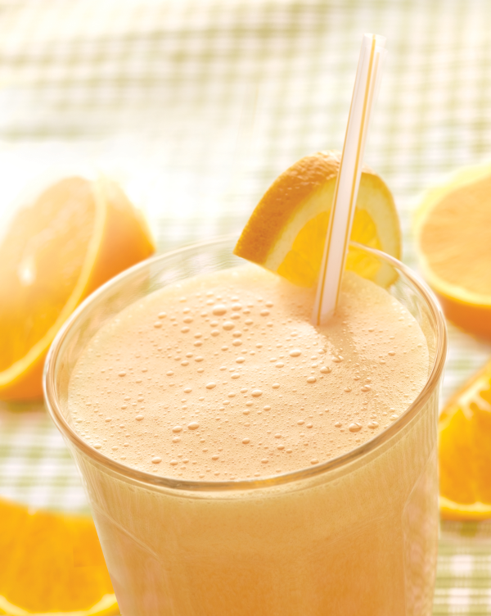

**ORANGE BOOSTER FLAX SMOOTHIE**

**Ingredients**

* 2 cups frozen peach slices
* 1 cup carrot juice
* 1 cup orange juice
* 2 tbsp ground flaxseed
* 1 tbsp chopped fresh ginger

**Instructions**

1. Combine peaches, carrot juice, orange juice, flaxseed and ginger in blender; blend until smooth. Serve immediately.

**Tip:** Look for ground flaxseeds (or flaxmeal) in the natural-foods section of large supermarkets or in natural-foods stores. Store in the refrigerator or freezer.

|  |  |  |  |
| --- | --- | --- | --- |
| **Nutritional Information (per serving)** | | | |
| Calories | 209 cals | Monounsaturated | 1 g |
| Protein | 5 g | Cholesterol | 0 mg |
| Carbohydrate | 41 g | Sodium | 38 mg |
| Total Fat | 4 g | Fiber | 6 g |
| Saturated Fat | 0 g | Makes 2 servings (1 ½ cup each) | |
| Nutrition Bonus: Vitamin A (467% daily value), Vitamin C (137% dv), Potassium (28% dv), Magnesium (20% dv) | | | |

Source: : <http://www.eatingwell.com/>