**Omega-3 fatty acids**, found in fish like salmon and tuna, can prevent surges in stress hormones and protect against heart disease, mood disorders like depression, and premenstrual syndrome. For a steady supply of omega-3s, aim to eat 3 ounces of fatty fish at least three times a week.

**Ingredients**

* 2 6-ounce cans chunk light tuna, drained
* ½ cup coarse dry whole-wheat breadcrumbs (or place 2 pieces of bread in a food processor)
* ½ cup low-fat mayonnaise, divided
* 1 4-ounce jar chopped pimientos, drained, or 1/3 cup chopped roasted red peppers, divided
* ½ cup finely chopped celery
* ¼ cup finely chopped onion
* ½ tsp Old Bay seasoning, divided
* 1 tbsp extra-virgin olive oil
* 4 whole-wheat hamburger buns or English muffins, toasted
* 4 lettuce leaves
* 4 slices tomato

**Quick Tuna Burgers**

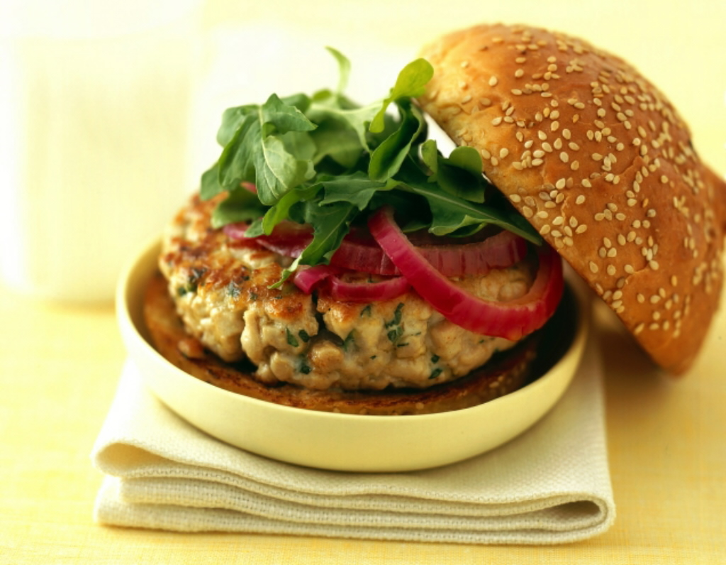

**Instructions**

1. Combine tuna, breadcrumbs, ¼ cup mayonnaise, half of the pimientos (or roasted red peppers), celery, onion and ¼ tsp Old Bay seasoning in a medium bowl, breaking up any larger pieces of tuna until the mixture is uniform and holds together.
2. Combine the remaining ¼ cup mayonnaise, the remaining pimientos (or peppers) and ¼ tsp Old Bay seasoning in a bowl.
3. Heat oil in a large nonstick skillet over medium heat. Using a generous 1/3 cup each, form the tuna mixture into four 3-inch burgers. Cook until heated through and golden brown, about 2 minutes per side.
4. Spread the top half of each bun (or English muffin) with pimiento mayonnaise and place a burger, lettuce and tomato on the bottom half.

|  |  |  |  |
| --- | --- | --- | --- |
| **Nutritional Information (per serving)** | | | |
| Calories | 321 | Monounsaturated Fat | 5 g |
| Protein | 17 g | Cholesterol | 20 mg |
| Carbohydrate | 39 g | Sodium | 647 mg |
| Total Fat | 12 g | Fiber | 5 g |
| Saturated Fat | 2 g | Makes 4 servings | |

Source: : <http://www.eatingwell.com/>