**Too little magnesium** may trigger headaches and fatigue, compounding the effects of stress. One cup of spinach goes a long way toward replenishing magnesium stores. Not a spinach eater? Try some cooked soybeans or a filet of salmon, also high in magnesium. Green leafy vegetables are a rich source of magnesium.

**Salmon Spinach Salad with Warm Mustard Vinaigrette**

**Ingredients**

* 4 salmon fillets, (about 3 oz/ 90 g each)
* ½ tsp pepper
* ¼ tsp salt
* 3 tbsp extra-virgin olive oil
* ½ small red onion, thinly sliced
* 2 tbsp grainy mustard
* 2 tbsp white wine vinegar
* 1 pkg (10 oz/284 g) fresh spinach
* Any additional desired fruits or vegetables

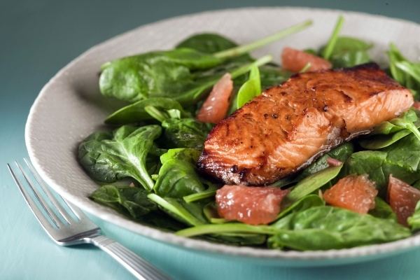

**Instructions**

1. Season salmon with half each of the pepper and salt. In large skillet, heat 1 tbsp (15 mL) of the oil over medium-high heat; add salmon, skin side down. Cover and fry, turning once, until fish flakes easily when tested, about 12 minutes. Transfer to plate and keep warm.
2. In same skillet, heat remaining oil over low heat; fry onion until softened, about 3 minutes. Whisk in mustard, vinegar and remaining salt and pepper.
3. In bowl, toss spinach and additional vegetables/fruit with vinaigrette. Divide among 4 plates; nestle salmon in centre.

|  |  |  |  |
| --- | --- | --- | --- |
| **Nutritional Information (per serving)** | | | |
| Calories | 241 cals | Potassium | 581 mg |
| Protein | 16 g | Cholesterol | 37 mg |
| Carbohydrate | 5 g | Sodium | 330 mg |
| Total Fat | 18 g | Fiber | 2 g |
| Saturated Fat | 3 g | Makes 4 servings | |

Source: <http://www.canadianliving.com/>