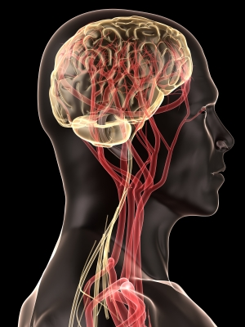 **Brain Health**

We often think that “staying fit” refers to the neck down. But, the health of your brain **plays a critical role in almost everything you do such as:** thinking**,** feeling**,** remembering**,** working**,** playing**,** and sleeping.

*There are things YOU CAN DO to help keep your brain healthier as you age. This may also reduce your risk of* ***Alzheimer’s disease*** *and* ***dementia****.*

**Brain-Healthy Lifestyle Choices**

1. **Eat a brain healthy diet**

* **Increase your intake of protective foods.** Try eating:
  + **Dark-skinned veggies**: kale, spinach, brussel sprouts, beets.
  + **Dark skinned fruits**: prunes, berries, plums, oranges, red grapes.
  + **Cold water fish**: halibut, mackerel, salmon, trout and tuna.
  + **Nuts with vitamin E**: almonds, pecans and walnuts
* **Vitamins may be helpful**. Vitamin E (or vitamin E with C), vitamin B12 and folate may be important in lowering your risk of developing Alzheimer’s.
* **Eliminate sugar and alcohol**.

There is an abundance of evidence suggesting a direct relationship between a healthy diet and brain size. Even small changes from a processed diet to a more whole food approach can have a big impact.



1. **Stay physically active**

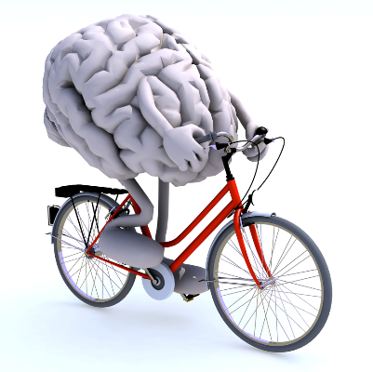

More evidence is showing that physical exercise *does not have to be strenuous or require a long duration*. It is most effective when done **regularly**, and in combination with a **brain-healthy diet**, **mental activity** and **social interaction**.

* Aerobic exercise improves **oxygen consumption** (which benefits brain function), and **reduces brain cell loss** in elderly subjects. Examples: walking, bicycling, gardening, tai chi, yoga.
* **Combine it with mental activity** byplotting your route, observing traffic signals, making choices.

1. **Remain Mentally Active**

Keep your brain active and challenged by introducing some small changes to your daily living. You do not have to make extreme lifestyle changes or sign up for school again, but **start with something small**, like a daily walk. After a while, add another small change.

 Stay mentally engaged in activities that stimulate the mind and body:

* Stay curious and involved in lifelong learning.
* Read, write, do crosswords, puzzles, and games.
* Attend lectures and plays
* Enroll in courses at your library, community college, or within your community.
* Try memory exercises.
* Join a dance class, arts class, or other social group and stay socially active.
* Travel and experience new cultures.

1. **Brain Benefits from Meditation**

Keeping our brains healthy and strong doesn’t always require keeping it active and engaged.

Allow time for **rest and repair**!

* Delays aging of the brain
* Changes the brain’s structures.
* Improve cognition and attention.

Find a meditation style that is a good fit for you.

This will ensure consistency so be realistic with your time

and expectations.

1. **Importance of Sleep**

A good night’s sleep may literally **clear your mind**!

* Time for housekeeping of the brain.
* Activates the glympathic system that helps to detox toxins and debris from the nervous system.
* A fit brain requires 7-8 hour of quality sleep.

Find a meditation style that is a good fit for you.

This will ensure consistency so be realistic with your time and expectations.

**Take Home Message!**

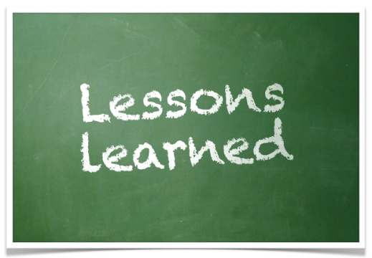

1. in health is critical for daily functioning like thinking, feeling, and working.
2. Eat a healthy diet full of good fats and antioxidants. Choose dark-skinned vegetables and fruit, nuts, and fish.
3. Stay physically active doing various kinds of aerobic activity.
4. Incorporate small ways to keep mentally active through games, puzzles, travel, or social activities.
5. Give your brain a timeout through rest and meditation.
6. Recognize the importance of quality sleep and aim for 7-8 hours per night.

***Lunch and Learn Sources:***

Alzheimer's Association. (2014). Brain Health. Retrieved from <http://www.alz.org/> <https://mayoclinic.pure.elsevier.com/en/publications/a-cognitive-training-program-based-on-principles-of-brain-plastic>

<https://www.hopkinsmedicine.org/health/healthy_aging/healthy_mind/keep-your-brain-young-with-music>

<https://www.laboratoryequipment.com/news/2016/08/study-use-it-or-lose-it-defend-against-memory-loss>

https://www.worldhealth.net/news/take-break-learnings-sake/

https://www.inc.com/tom-popomaronis/how-exercise-makes-your-brain-bigger-better-and-stronger.html

<http://scienceline.org/2014/03/why-is-salmon-good-for-your-brain/>

<https://www.livescience.com/35571-walnuts-healthy-antioxidants.html>

<https://www.verywellmind.com/meditation-made-simple-meditation-for-beginners-3144773>

<https://www.sciencedaily.com/releases/2011/01/110121144007.htm>

Lauders, E., N. Cherbuin and C. Gaser (2016). “Estimating brain age using high-resolution pattern recognition: Younger brains in long-term meditation practitioners.” Neuroimage **134**: 508-513.

<http://jtoomim.org/brain-training/Zeidan2010_Mindfulness_Meditation.pdf>

<http://social-psychiatry.com/jigsaw-puzzles-good-brain/>

https://www.sciencedaily.com/releases/2017/07/170717091029.htm

https://www.ncbi.nlm.nih.gov/pmc/articles/PMC3758967/

<https://www.aarp.org/health/brain-health/info-2014/sleep-for-brain-health.html>

https://www.nih.gov/news-events/news-releases/brain-may-flushout-toxins-during-sleep