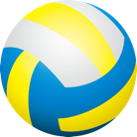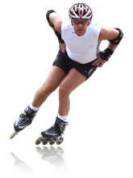**Here is a blank sheet so that you can decide which activities you want to enjoy this summer!**

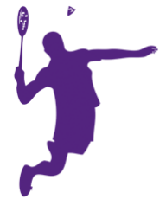

|  |  |  |  |  |
| --- | --- | --- | --- | --- |
| **B** | **I** | **N** | **G** | **O** |
|  |  |  |  |  |
|  |  |  |  |  |
|  |  |  |  |  |
|  |  |  |  |  |
|  |  |  |  |  |

****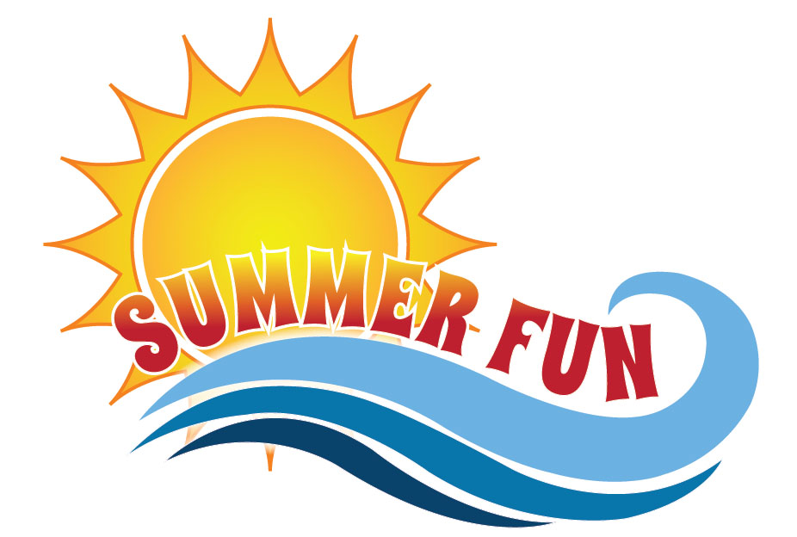

**List of outdoor activities:**

Running, walking, hiking, soccer, basketball, baseball, tag, frisbee, beach volleyball, golf, badminton, biking, skateboarding, swimming, kayaking, canoeing, outdoor yoga, kite surfing, paddle boarding, windsurfing, roller blading, gardening, lawn bowling, lawn darts, horseshoes, bocce ball, hacky sack, croquet, horseback riding, motorcross, water polo, wakeboarding, jet skiing, water skiing, outdoor bootcamp, snorkeling, white water rafting, football, dancing, handball, paintballing, rock climbing, street hockey, biking – the list goes on!

*What else have you always wanted to try? Check out Canada’s 150 playlist for more great ideas.*

***www.participaction.com/en-ca/programs/participaction-150-play-list***

**Sun Safety Tips:**

* Peak sun hours are between 10am and 4pm
* UV rays can bounce off surfaces such as the sand and water
* Sunscreen needs to be reapplied every 45-60mins
  + After swimming, perspiring, and toweling off
* Have sunscreen coverage for lips, neck, and ears
* Stay in the shade often
* Being hydrated is also important to avoid heat stress
* Here’s a handy app to help you know the time to burn in your area - QSun

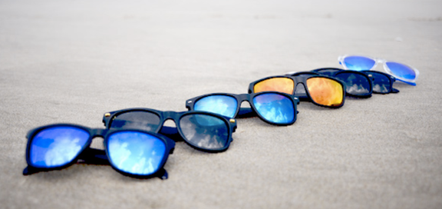

**Sun Smart Clothing:**

* Light-coloured clothing will keep you cool, but darker colours give more protection from the sun
* Long-sleeved shirts and long pants
* Wide-brimmed hat with breathable fabric
* Sunglasses (dark lenses) with UVA and UVB protection
* For children or people with higher risk factors, investing in clothing with SPF material is a good idea

Source: www.sunsafetyalliance.org



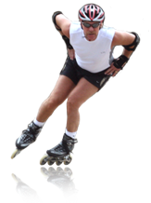

Complete the BINGO sheet by participating in as many outdoor activities as posssible. Decide how you want to celebrate your accomplishment!

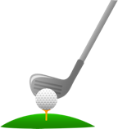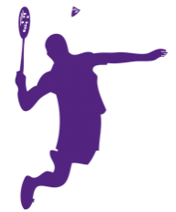

|  |  |  |  |  |
| --- | --- | --- | --- | --- |
| **B** | **I** | **N** | **G** | **O** |
| RUNNING | VOLLEYBALL | SOCCER | OUTDOOR YOGA | LAWN BOWLING |
| WATER SKIING | WALKING | GOLF | BASEBALL | WAKEBOARDING |
| BADMINTON | BASKETBALL | **FREE** | SWIMMING | GOING TO THE PARK |
| CROQUET | WATER POLO | KAYAKING | FRISBEE | HACKY SACK |
| SURFING | SKATEBOARDING | BIKING | HORSEBACK RIDING | ROLLER BLADING |