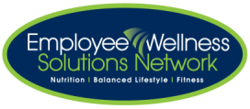

**Clean Popcorn**

Whether your “weakness” is sugar or salty snacks we all crave something in the not-so-healthy category every once in a while. Here we have a great healthier snack option for you to try. POPCORN! This crunchy snack is easy to make with a variety of different flavours that will curb your cravings for sure! Eat it at home for movie night or occasionally pack a small bag for a snack during your day. Making it at home allows you to control how much salt or other flavours you may want to add.

**Microwavable vs. Air-Popped Popcorn (per cup)**

|  |  |
| --- | --- |
| **Microwavable** | **Air-Popped** |
| 64 calories | 31 calories |
| 4.8 g of fat | 0.34 g of fat |
| 0.9 g of fiber | 1.2 g of fiber |

The smell of the synthetic butter is from a chemical called diacetyl. Organizations suggest this chemical is hazardous if inhaled for long periods of time. Diacetyl can affect the health of lungs. Thankfully, making air-popped popcorn allows you to enjoy it without the dangerous chemicals.

Source: [www.healthyeating.sfgate.com](http://www.healthyeating.sfgate.com)

Source: [www.livestrong.com](http://www.livestrong.com)

**How to Make Clean Popcorn**

* 1/3 of kernels
* 1 teaspoon of olive oil

Add 1/3 of kernels to a brown paper lunch bag. Add 1 teaspoon of olive oil and press the “popcorn” button on the microwave.

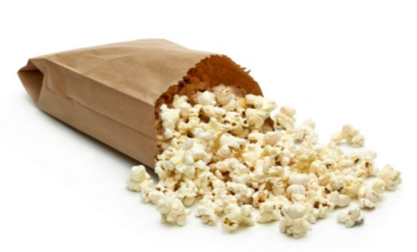



*Source:* [*www.webmd.com*](http://www.webmd.com)*, healthland.time.com*

**Other Topping Alternatives**

* Coconut oil
* Sea salt
* Cocoa powder, unsweetened
* Cinnamon
* Lemon zest
* Ground cumin
* Chipotle powder
* Lime zest
* Garlic powder
* Parmesan

**Spicy Popcorn Recipe**

* 1 teaspoon chili powder
* ¼ teaspoon paprika
* ¼ teaspoon salt
* 2 tablespoons unsalted butter (melted**)**
* Pop 1 cup of popcorn as per above or on the stove top and then pour the melted butter and seasoning on top.

Source: [www.myrecipes.com](http://www.myrecipes.com)

