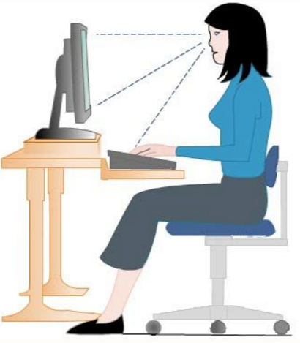

**October 10 – October 14, 2016**

**Week Two – Feeling Great with Family & Friends**

This week's focus is family and friends, and the importance of maintaining a healthy work/life balance.



Lots of Thanksgiving leftovers and don’t know what to do with them? The Thanksgiving feast doesn’t end! Here’s one simple and healthy recipe for you to try.

**Leftover Turkey Frittata (Serves 4-6)**

|  |  |
| --- | --- |
| • 8 eggs | • 2 cups shredded brussels sprouts |
| • Kosher salt and freshly ground black pepper | • 3/4 lb roast turkey, shredded (about 2 cups) |
| • 1 jalapeno, deseeded, and sliced (about 2 tbsp) | • 1 cup green beans, trimmed and cut into 1-inch pieces |
| • 1 shallot, thinly sliced (About ½ cup) | • 1/2 cup fresh chopped parsley, for garnish |
| • 2 tbsp olive oil |  |

1. Season eggs with salt and pepper and beat until foamy in bowl.
2. Heat oil in skillet over medium-high. Add shallots, jalapeno, pinch of salt, and cook until softened, about 2 minutes.
3. Add the brussels and green beans and cook until they start to crisp, about 2 to 3 minutes.
4. Add the roast turkey to the skillet and stir the ingredients together for 1 minute, spreading them evenly on the bottom of the pan. Lower the heat to medium-low.
5. Shake the pan to make sure it’s evenly distributed. Cover the pan until the egg is lightly browned on the bottom, 3 to 5 minutes.
6. Flip the frittata and cook the bottom until slightly browned, 1 to 2 minutes more.

*Source*: www.seriouseats.com

