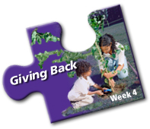

**October 24 – October 28, 2016**

**Week Four – Feeling Great Giving Back**

Social responsibility is the focus for week four. Support corporate social responsibility; sponsor a day at Habitat for Humanity; promote the concept of volunteerism as a business learning opportunity (volunteer for a board of a community association, not for profit entity, food bank, etc.). There are many activities your organization can take part in: food bank drives; blood donation drive; sponsorship of a little league team; leaf raking for seniors; signing organ donation cards; United Way initiatives or hundreds of other activities. It's a great way for individuals and organizations to give back to the community!

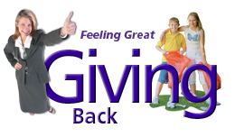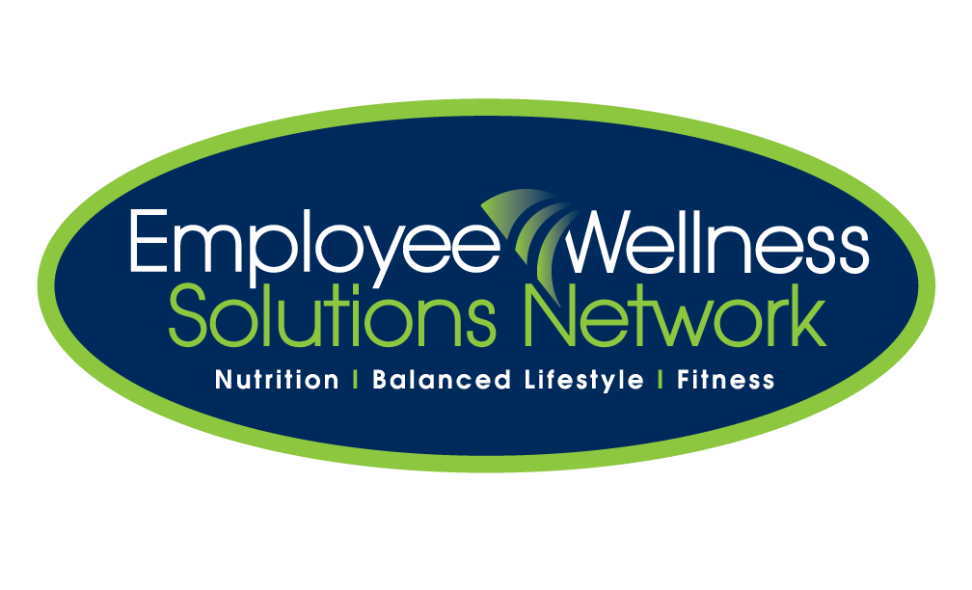

We encourage you to try implementing some of these things into your week with your organization.

1. Get together with some colleagues and organize a book collection drive.
2. Co-ordinate an organ donation donor card signing event. Printable wallet donor cards and forms are attached.
3. Encourage your co-workers to save a life and donate blood this week.
4. Volunteer to help keep your neighbourhood children safe by organizing a community watch program on Halloween night.
5. Plant a tree on the grounds of your workplace honouring a special employee who goes out of his or his/her way to encourage healthy practices in the workplace.