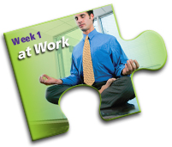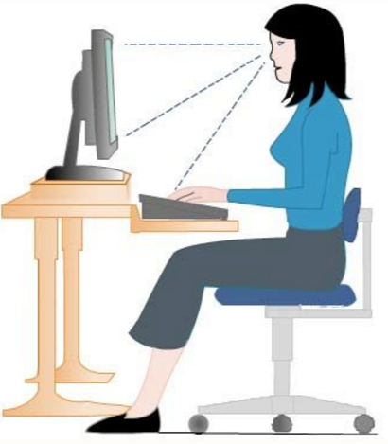

Kick off Healthy Workplace Month focusing on the workplace. Although we all have a job to do it's possible to incorporate healthy living and activities into our working hours. You and your organization will be more productive and happier for it.

**October 3 – October 7, 2016**

**Week One – Feeling Great at Work**

We encourage you to try implement some of these ideas, tips, and tasks into your work week.





1. Re-organize your work station.
2. Do a mini ergonomic assessment of your work station. Follow these tips:

* top of monitor level with eyes
* keyboard is ~15° below horizontal eye level
* keyboard is centered in front of you (key B is directly in front of you)
* negative slope (wrists free of surface pressure contact)
* mouse should be close to your body
* whole arm movements (move mouse with shoulder, not wrist)
* chair should be able to adjust up and down and have 5 wheels
* elbows, hips, knees, ankles at 90 degree angles while feet are resting flat on the floor
* change positions frequently
* every 60 minutes take a break! Get up and walk around the office
* every 20 minutes look away from the screen for 20 seconds

1. Start a checklist of good work habits you possess or would like to possess.
2. List your work stressors.
3. Practice stress busters at work. Try this breathing method:

Sit with your feet flat on the floor. Breathe in through your nose and let your stomach and chest rise. Exhale through your mouth and let your stomach and chest fall. Repeat 3 or 4 times, allowing yourself to relax a little more with each exhale.

1. Do some desk stretches.
2. Take a proper lunch break. Do not eat at your desk while working.
3. Get outside for a brisk walk on your break and/or lunch hour. Invite some of your colleagues to join you.
4. Take a look at the article called “A Shift of Attention in the Workplace” for more great tips on how you can improve the health of your workplace.

*Source*: Health Canada, healthyworkplaceweek.ca