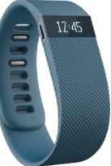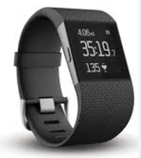

Do you have a Fit Bit? Did you know that you can track your heart rate on it? Decrease your heart rate this month through: meditation, exercise, sleep, and nutrition. If you do not have a Fit Bit, you can still participate in this challenge by manually counting how many pulses you feel in a minute.

Join In!!

Contact _____________

By _________________.

***Generally, a lower resting heart rate means a healthier heart and better cardiovascular fitness!***

**Fit Bit Heart Rate Activity – Drop it Low**