

**Fit Bit Heart Rate Activity**

**Drop It Low Instructions**

Goal: To decrease your resting heart rate

Before you begin, track your resting heart rate on your Fit Bit. If you do not have a Fit Bit, you can use another fitness device or you can manually check your heart rate. Record this number.

Each week, you’ll get information about how you can decrease your heart rate.

Week 1: Meditation

Week 2: Sleep

Week 3: Cardiovascular Exercise

Week 4: Hydration

Keep track of your resting heart rate after each week. By the end of the month, see if your resting heart rate has changed or not.

A healthy heart has a resting heart rate between **60-80 beats per minute** (Heart and Stroke Foundation).

fadf

Aajdkas

Ad

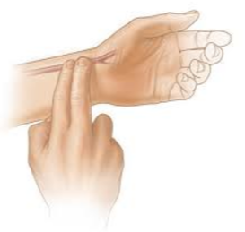

**How to Manually Take Your Resting Heart Rate**

There are two common ways:

1. Check your pulse on the inside of your wrist.
2. Check your pulse on the carotid artery. It is located below the jawline on the side of your windpipe.

* Count how many pulses in 15 seconds, and multiple that number by 4
* Use your index and third finger to feel pulse
* There are lots of factors that could influence your resting heart rate such as emotions, medications, body position, air temperature, etc.
* Measure your heart rate at consistent times

