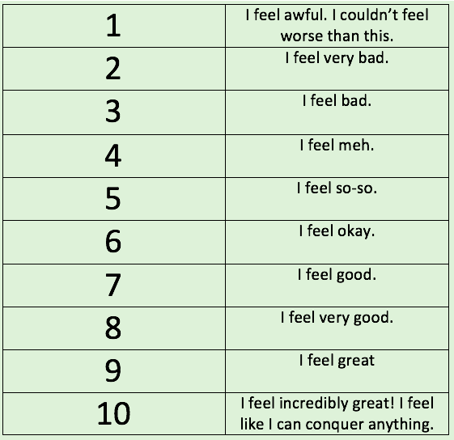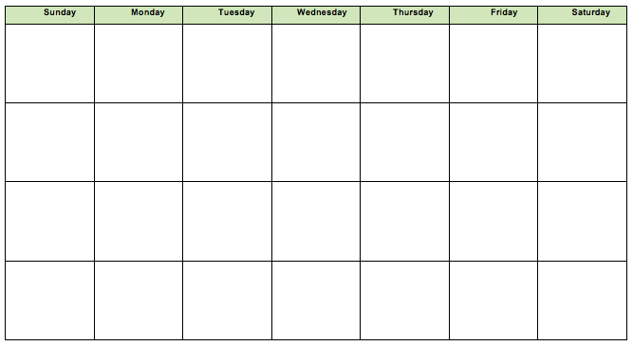

Join us in our ***Crappy to Happy*** experiment! For week 1, keep your current exercise schedule, even if that means you aren’t exercising. Rate your mood everyday around the same time each day for consistency (i.e. rate your mood at 6pm). Then exercise 5 out of 7 days for the next 3 weeks (Intensity will be determined with your coach). Rate your mood after each workout, and on the 2 days you don’t workout. Calculate your daily average from week 1, and from weeks 2-4 and compare the two values and see if there is there is a difference!

Interested? Contact _______ @ _________________.

***Exercise has been shown to be a positive tool to improve your mood, mental health, and overall well-being.***

**Crappy to Happy**