********

**Olympics 2016 – Brazil!**



The anticipated 2016 Summer Olympic Games are going to take place in Rio, Brazil. Did you know that Brazil was named after a tree called Brazilwood? Reports say that the Rio’s athletes’ village will be the biggest in Olympic history!

Brazil is known for açaí. Açaí, which are grape-shaped fruit, are found in floodplains. They have a high concentration of antioxidants that may be able to counteract oxidative damage. You can find açaí juice, powder, or frozen açaí found in most natural food stores.

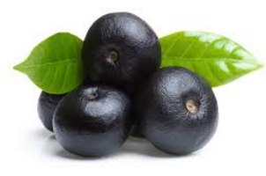  

**Berry Açaí Bowl (Serves 1)**

Smoothie Ingredients:

* 2/3 cup frozen blueberries
* 2/3 cup frozen strawberries
* 1/2 banana
* 3/4-1 cup almond milk (or regular milk)
* açaí of choice (1 scoop powder or ½ cup frozen or replace milk with açaí juice)

Topping Ingredients:

* ½ banana, sliced
* fresh blueberries
* fresh strawberries, sliced
* granola
* coconut flakes

Directions:

1. blend all the smoothie ingredients together until smooth
2. pour smoothie mixture in bowl
3. top with desired ingredients