

**Energy Drinks**

You need to stay awake. What do you typically drink/eat? Coffee? Caffeine pills? Energy drinks? Energy drinks are a booming industry, yet there are so many health risks associated with them (Breda et al., 2014). The availability and marketing of energy drinks are enabling consumers to purchase these caffeinated-loaded drinks. Energy drinks can contain up to 50 to 500 mg of caffeine – 500 mg of caffeine is equivalent to 5 cups of coffee. There are healthier ways to have more energy which don’t require the purchase of these drinks - exercising, sleeping, and eating nutritious meals!

**Risks of Energy Drinks**

* Irregular heart beat
* Nausea and vomiting
* Severe headaches
* Unhealthy for teeth
* Insomnia
* Extreme dehydration
* Weight gain
* Addiction
* High blood pressure
* Negative behavioural outcomes
* Feeling fatigued after caffeine has worn off
* Death (in rare cases)

(Breda et al., 2014)

**Comparison of Energy Drinks**

|  |  |  |  |  |  |
| --- | --- | --- | --- | --- | --- |
| Product | Size (fl. Oz) | Cost | Calories | Sugar (g) | Caffeine (mg) |
| Rockstar Energy Drink Double Strength | 8 | 1.00 | 140 | 31 | 80 |
| Red Bull | 8.4 | 1.75 | 110 | 27 | 83 |
| Monster | 8 | 1.00 | 100 | 27 | 92 |
| 5-hour Energy | 1.9 | 2.00 | 4 | 0 | 215 |
| 5-hour Energy Extra Strength | 1.9 | 3.00 | 4 | 0 | 242 |

(source: www.consumerreports.org)

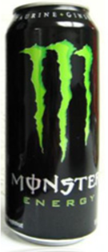



*Source:* [*www.webmd.com*](http://www.webmd.com)*, healthland.time.com*

**How to Stay Hydrated**

Caffeine acts as a diuretic which causes the body to lose water. It’s important to stay hydrated by drinking water and consuming foods with high water content. Water helps to lubricate your joints, transport nutrients, and allows your body to perform in its highest function.

What Ingredients Are Commonly Found in Energy Drinks?

* Sucrose/Glucose 🡪 too much can lead to weight gain and cavities
* Sodium Citrate 🡪 erode teeth enamel
* Taurine 🡪 unknown
* Caffeine 🡪 increase mental awareness, but too much can produce anxiety

(source: www.precisionnutrition.com)

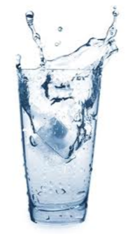

Breda, J., Whiting, S., Encarnação, R., Norberg, S., Jones, R., Reinap, M., & Jewell, J. (2014). Energy Drink Consumption in Europe: A Review of the Risks, Adverse Health Effects, and Policy Options to Respond. *Frontiers In Public Health*, *2*. http://dx.doi.org/10.3389/fpubh.2014.00134

