

**What is a myofascial trigger point?**

Myofascial trigger points, commonly known as muscle knots, are sensitive points on your body that cause pain and irritation. It is not the same soreness as you get from after a regular workout. Myofascial trigger points are muscles fibres that are clenched together causing aching and stiffness. When the trigger point is pushed, it will be painful. Most trigger points occur on your back and neck.

**Self-Massage Myofascial Release**

**Importance of releasing trigger points**

* Releases tight muscles
* Helps with pain
* Helps with injury prevention
* Increases blood flow to help you recover faster
* De-stresses your body

**How to release trigger points**

You can release the trigger points by applying pressure using a foam roller, tennis ball, or a golf ball. Avoid applying pressure on the bone or joint - only apply pressure on the muscle.

Hold the tennis ball on your back and lean against the wall. Move up and down and side to side to find the trigger point. Once you have located one, hold the pressure there for 10 to 100 seconds or apply small kneading strokes around the trigger point to break up tight tissue and increase blood flow. You can also do this by putting the tennis ball on the floor and lying on your back.

**What you can use to release trigger points**

* Foam roller
* Tennis ball
* Golf ball



*Source:* [*www.webmd.com*](http://www.webmd.com)*, healthland.time.com*

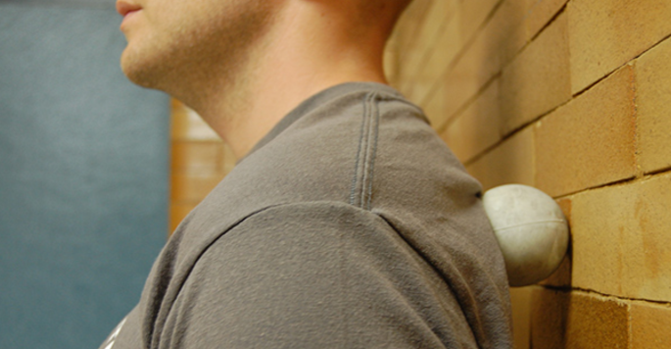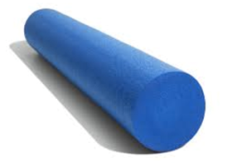

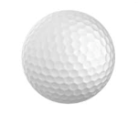

**What should it feel like?**

It should be a “good pain” that is tolerable. Pressure on trigger points should feel satisfying and relieving. If you are wincing or gritting your teeth while releasing a trigger point, you may have to be more gentile.





Source: www.painscience.com