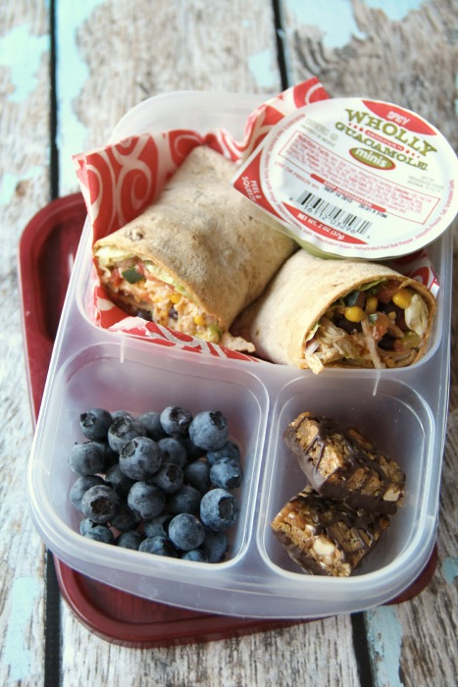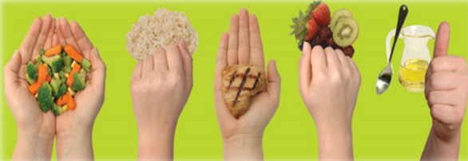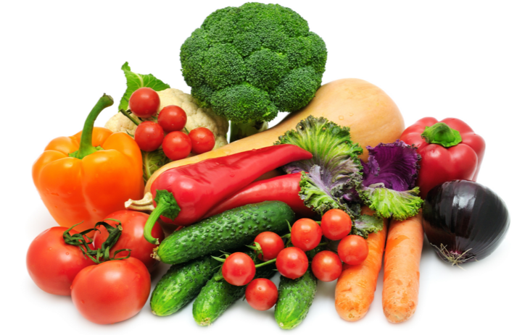Look at My Lunch

**Recommended Number of Food Guide Servings Per Day**

|  |  |  |  |  |
| --- | --- | --- | --- | --- |
|  | **Adults** | | | |
|  | **19-50 Years** | | **51+ Years** | |
| **Female** | **Male** | **Female** | **Male** |
| **Vegetables and Fruit** | 7-8 | 8-10 | 7 | 7 |
| **Grain Products** | 6-7 | 8 | 6 | 7 |
| **Milk and Alternatives** | 2 | 2 | 3 | 3 |
| **Meat and Alternatives** | 2 | 3 | 2 | 3 |

**What Does a Serving Look Like?**

2 hands = a cup (for veggies)

1 hand = ½ cup (whole grains, rice, or fruit)

Palm of hand or deck of cards = 3-4oz (protein)

Thumb = 1 tbsp (for healthy fats like olive oil)

**1/4**

**Whole Grains**

**1/4**

**Lean Protein**

**1/2**

**Fruits and Vegetables**

**A Balanced Lunch**