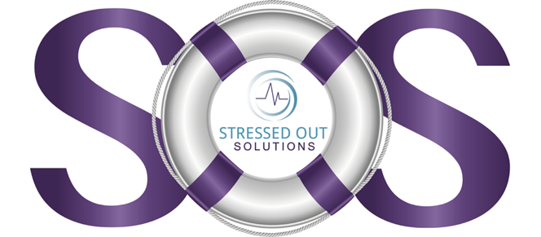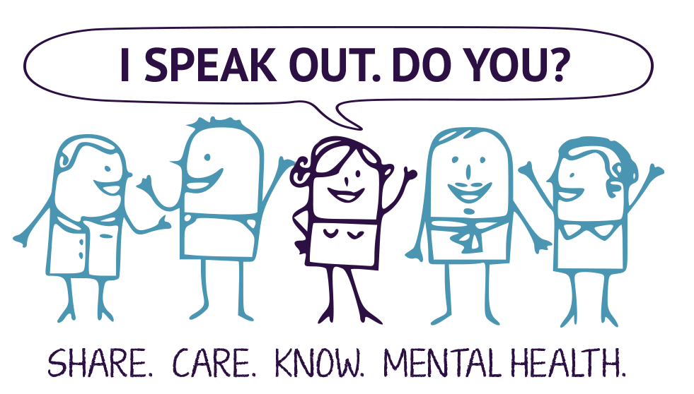

Mental Health Month is here!

Join us on __________________ for a fun and interactive game of jeopardy! The topics will be on mental health facts, depression, anxiety, identifying the signs, and brain food. Are you ready for this jeopardy challenge? How many points do you think you can accumulate?

**Stop the Silence Jeopardy Challenge**