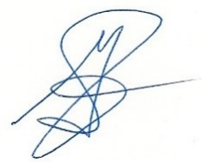

This is to certify that

Garth Jansen

Has successfully completed the

**Workplace Wellness Committee Certification.**

Certificate issued on

**December 11th, 2015**

**Garth Jansen**

EWSNetwork President

**Meaghan Jansen**

WWCC Trainer