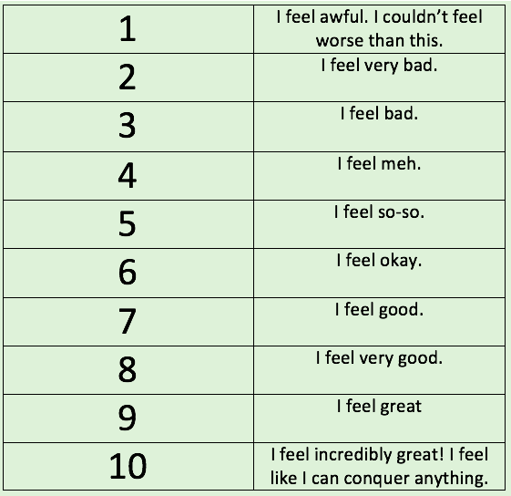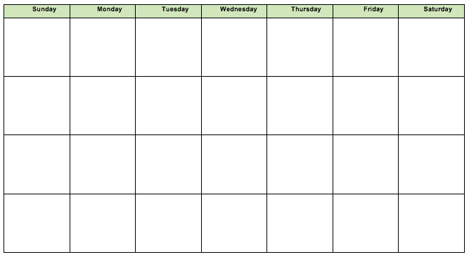

Join us in our ***Crappy to Happy*** experiment! For week 1, keep your current exercise schedule, even if that means you aren’t exercising. Rate your mood everyday around the same time each for consistency (i.e. rate your mood at 6pm). Then exercise 5 out of 7 days for the next 3 weeks (Intensity will be determined with your coach). Rate your mood after each workout, and on the 2 days you don’t workout. Calculate your daily average from week 1, and from weeks 2-4 and compare the two values and see if there is a difference!

Track your physical activity using the calendar provided. Remember that they have to be at least 20 minutes and within the intensity you and your coach have determined.

***Find out for yourself if exercise is friend or foe! Just when you don’t feel like working out, is likely when you need it the most!***

This is the mood rating scale. Assign yourself a mood after each workout and on days when you do not work out. Remember to keep track of your numbers on the tracking calendar!

**Crappy to Happy**