Do you want to quit smoking cigarettes?

The STOP program delivers research-based, cost-free smoking cessation workshops in local communities.

Eligible participants will:
☑ Attend an educational session
☑ Receive a five-week course of nicotine patches

Workshops will be held on:
Wednesday August 12, 2015 from
6 to 9 p.m. in Kitchener

To learn more, see if you qualify, and to register, contact:
Region of Waterloo Public Health
519-575-4400 (TTY 519-575-4608)

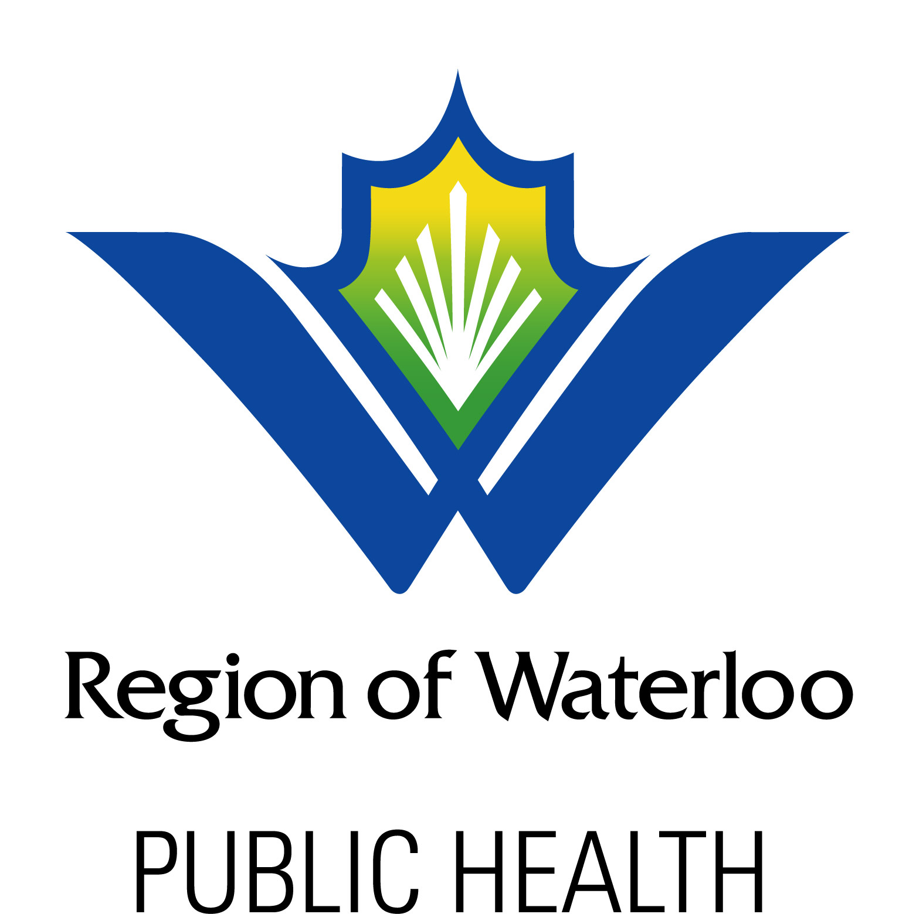
*Confidentiality assured
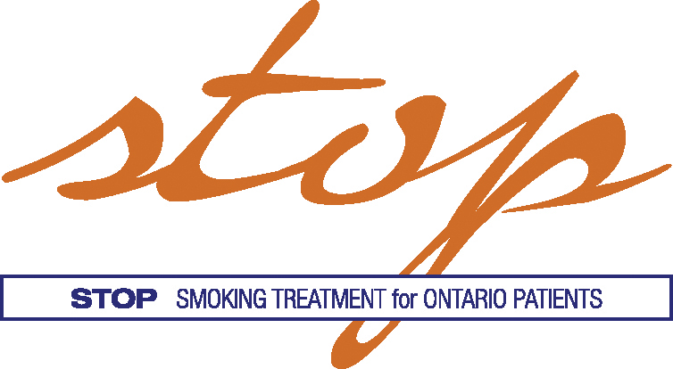
.
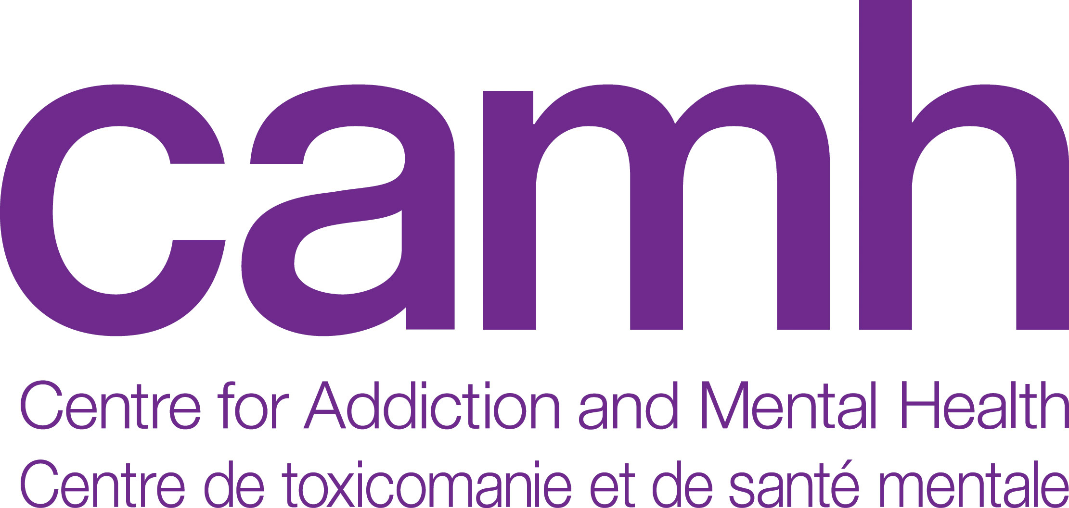
For more detailed information on the STOP program, please call 416-535-8501 x34455 or email stop.study@camh.ca. CAMH is a research and teaching hospital fully affiliated with the University of Toronto and is a Pan American Health Organization/World Health Organization Collaborating Centre. For information on other CAMH treatment programs and services, visit www.camh.ca or call 416-535-8501 (1-800-463-6273).

Quit Smoking Workshop
519-575-4400

Quit Smoking Workshop
519-575-4400

Quit Smoking Workshop
519-575-4400

Quit Smoking Workshop
519-575-4400

Quit Smoking Workshop
519-575-4400

Quit Smoking Workshop
519-575-4400

Quit Smoking Workshop
519-575-4400

Quit Smoking Workshop
519-575-4400

