On the Road Again

Wellness Scavenger Hunt

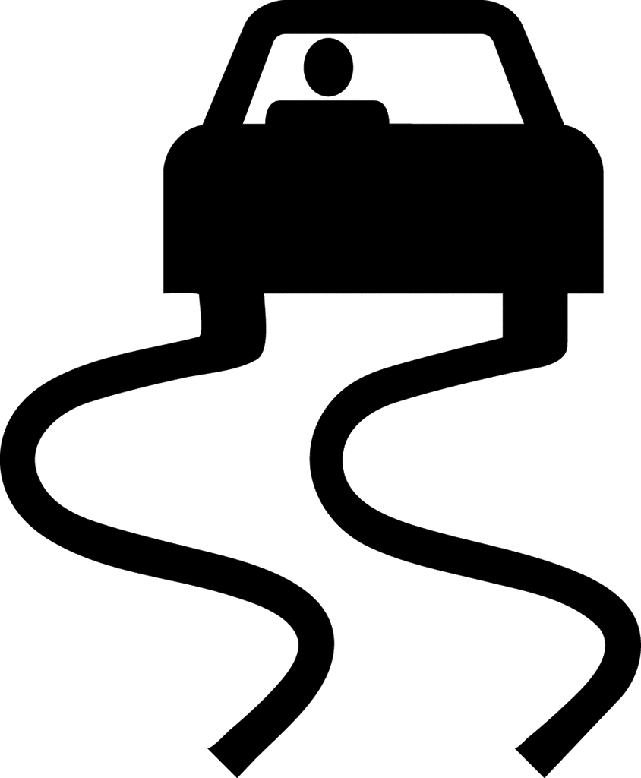

**YOUR TASK: Find and complete as many items as you can on the checklist each week. Points are awarded for each item that is completed. Additional points are given as the level of difficulty increases.**

**WHEN:** [*INSERT DATE (4 weeks)]*

**WHY:** When you spend a lot of time on the road, it’s hard to stay healthy and energized without a consistent routine. This challenge aims to help you make the right choices and become more aware of healthier options while on the road.

**SCORING:** Each week, points will be added up. A prize will be given to the participant who has the most points. In the case of a tie, a winner will be randomly drawn.

