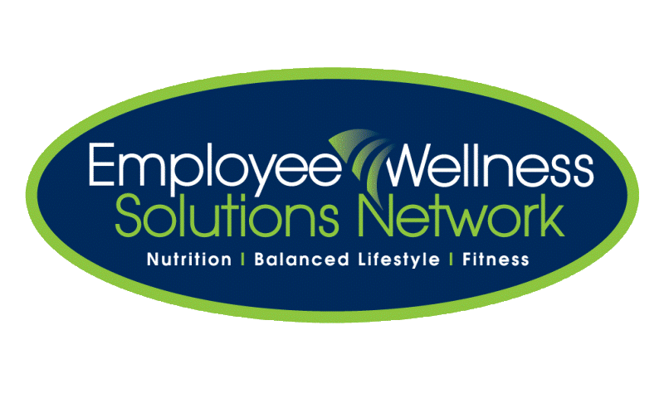
Wellness Consultations

Private, 100% Confidential, Voluntary

Nutrition
Exercise
Education, Motivation, Inspiration
It starts with “just a conversation”!

Healthy eating tips (recipes, meal plans, quick meal prep)  Grocery shopping tips  Sports nutrition  Managing food intolerances  Vitamins and supplements  Children and youth nutrition  Specialty food options (organic, vegetarian) | Types of exercise  Fitness program design (strength)  Walking programs  Learn to run programs  Yoga and stretching  Exercise for the aging population
Disease Prevention
Lifestyle

Diabetes management/prevention  Cholesterol and blood pressure management Quitting smoking  Injury management  Healthy aging ( how to manage osteoporosis) | Goal setting (and achieving!)  Time management  Self-confidence (finding joy, combat negative attitudes)  Coping with depression
Coping with Stress
Weight Loss

Stress management  Relaxation and breathing techniques  Sleep strategies  How to overcome setbacks  Do any of these items impact you or your family? | Healthy weight loss  Healthy body composition  Monitoring calories  Detoxing (why, how, risks)

* Referral to additional resources as needed*
If so, connect with your EWSNetwork wellness consultant
First name, last name name@ewsnetwork.com | First name, last name name@ewsnetwork.com | First name, last name name@ewsnetwork.com | First name, last name name@ewsnetwork.com | First name, last name name@ewsnetwork.com | First name, last name name@ewsnetwork.com | First name, last name name@ewsnetwork.com | First name, last name name@ewsnetwork.com

©2012 Employee Wellness Solutions Network™ - 1-1 Consultations. All rights reserved.

