The Employee Wellness Solutions Network wellness program at Century Group involves a variety of wellness initiatives – individual, group (interactive), and awareness programming. There is something for everyone!
Century Group Wellness Program Program

EWSNetwork takes a multi-faceted approach to wellness.

1. One-on-One Lifestyle/ Wellness Consultations
By meeting with a consultant one-on-one, you have access to individualized meal planning and exercise routines, personalized strategies for weight loss/maintenance, stress management tools, injury-prevention, back health …. and any other questions (ie: nutrition, physical activity, stress, time management, sleep, etc.) regarding your overall health. Do you want to get back to the gym or workout at home? Get a routine set up. Do you have hypertension or high cholesterol? Learn about some strategies to lower these. Are you diabetic? Gather information about meal planning. Do you suffer from back pain? Learn which exercises are the most beneficial for you. The services for you are endless.

In other words, your very own personal coach / nutritionist / personal trainer / wellness specialist right here on-site!

Health Coach: Whitney Coupland
wcoupland@EWSNetwork.com

2. Interactive (group) Initiatives
The group initiatives conducted by EWSNetwork may include lunch n’ learns, incentive programs (win prizes!), exercise initiatives/on-site exercise classes, nutrition programs, Work-Life Balance programs, healthy eating programs, lifestyle programming (diabetes, heart health, time management, stress management, etc) and health fairs. The goal of these initiatives is to offer a wide variety of programs with the intent to attract different types of people, with different interests, into the program.

3. Awareness Initiatives/Campaigns
The awareness initiatives include kiosks, posters, bulletin boards, newsletters, recipes and wellness challenges.


Questions & Answers

Is the Wellness Program a weight loss program? If weight loss is your goal, we will most certainly provide you with all of the knowledge, tools, support, and motivation you need to achieve your goal. However, we are not strictly a weight loss program. Instead, we take a multi-faceted approach to helping you live a healthy lifestyle.

How do I set up an appointment to discuss some of my health goals? Simply send an e-mail to wcoupland@EWSNetwork.com to request an appointment.

Is it important that I keep my appointment even if I have not done what I said I would? Yes. It is very important to attend your appointment, especially if you haven’t been focusing on your goals. The consultant will help you get refocused and get you back on your way toward success.

There is something offered for everyone. Don’t miss out on this marvellous opportunity. Your organization cares for you and your health – so do we!

Heather Barrett
EWSNetwork Program Director
hbarrett@EWSNetwork.com
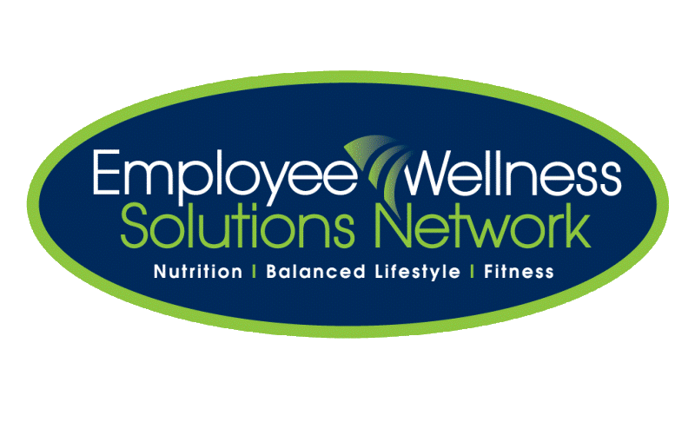

Do you have a health question or concern?
Log on and check out our easy to use Resource Centre.

Here is what a few are saying…

“After joining a fitness club and watching my diet, I felt that there was something missing in my total health program. The executive director talked about the Wellness Program and I thought "It is worth a visit". The consultant was enthusiastic and willing to work with my needs, not fit me into a box. The meeting was encouraging and a plan was put in place. I am proud that I want to be a healthier employee. The consultant has given me realistic goals and I look forward to our next meeting.”

“The Wellness program has come at a crucial time in my life. The consultant has helped me to focus on my goals which are weight loss and stress relief. I truly look forward to my personal appointments, as I receive helpful guidance and support in a comfortable atmosphere. It is wonderful to know that the agency I work for cares enough about me to offer a program that will help me and my colleagues in their personal lives and consequently affect our overall happiness. Thank you EWSNetwork!”

“Very positive approach - through the core exercises provided to me I have noticed a difference in core strength.”

“I realized that my response to stress can determine its impact on my body.”

“I would like to thank you for coming into my life… When I started participating in the wellness program, I found out a whole other world of health was waiting for me… I feel fantastic, better than I have every felt before. I attribute all of this to Employee Wellness Solutions Network!.”

NEW WEBSITE
www.EWSNetwork.com
One-on-One Wellness Consultations

Voluntary, Private, 100% Confidential

A one-on-one wellness consultation with a Wellness Consultant is designed to educate, motivate, and inspire you to reach your health and wellness goals. It starts with “just a conversation”….

What can a wellness consultation cover?
A wellness consultant is there to help YOU! A consultant has the knowledge and skills to discuss a number of wellness topics, including:

Do any of these items impact
you or your family?

/


* Referral to additional resources as needed *

Nutrition | Exercise
- Healthy eating tips  - Sports nutrition  - Vitamins and supplements  - Specialty food options (organic, vegetarian)  - Grocery shopping tips  - Managing food intolerances  - Children and youth nutrition  - Recipes, meal plans, quick meal preparation | - Types of exercise  - Fitness program design  - Walking programs  - Learn to run programs  - Yoga and stretching  - Exercise for the aging population

Disease Prevention | Lifestyle
- Diabetes prevention and management  - Quitting smoking  - Injury management  - Cholesterol and blood pressure management  - Healthy aging (how to manage osteoporosis) | - Goal setting (and achieving!)  - Self-confidence (joy, combat negativity)  - Time management strategies  - Coping with depression

Coping with Stress | Weight Loss
- Stress management  - Relaxation and breathing techniques  - Sleep strategies  - How to overcome setbacks | - Healthy weight loss  - Monitoring calories  - Healthy body composition  - Detoxing (why, how, risks)

