Presenting the Century Group

Health & Wellness Program

Coming on September 25th
We are launching a NEW Employee
Health & Wellness Program!!

LAUNCH SCHEDULE

Century Group Wellness Program Launch

during Company Meeting on Sept 25th.

Staff Information Sessions and Program Launches
You are invited to attend the Century Group Wellness Program Launch on Thursday, September 25th during the Company Meeting. Meaghan Jansen of Employee Wellness Solutions Network [EWSNetwork] will be sharing the wellness program details. Take this opportunity to meet some of the EWSNetwork Wellness Team and get signed up for some initial wellness programs.

  - Enjoy a fruit smoothie following the launch
  - Complete your Personal Wellness Profile and receive a chance at winning $500!


Starting on Wednesday Oct 1….
One-on-One Wellness Consultations
This is your opportunity to work with a wellness coach, for FREE. Get information pertaining to nutrition, exercise, sleep improvement, stress management, and so much more! You can discuss any of your personal wellness goals with our certified wellness specialist. Details will be shared on launch day.


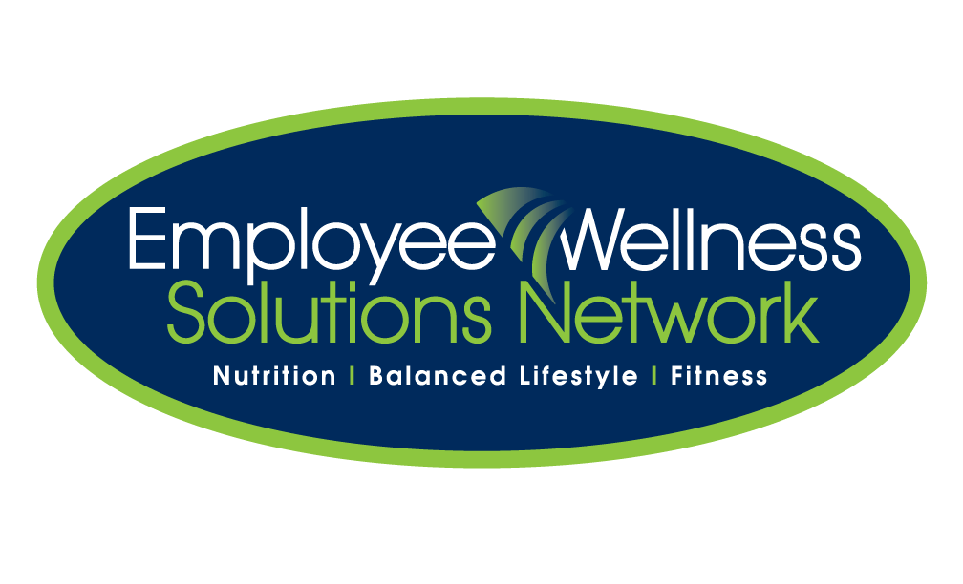
Services Provided by:

