
Employee Wellness Solutions Network
Personal Wellness Profile [Health Questionnaire]

Log-in Website
www.EWSNetwork.com/centurygroup

Step #1
Read instructions, scroll down, and click START

Step #2
Click NEW USER REGISTRATION
(Find in the top left hand corner.)

Step #3
Create and Enter Username, password
and fill in other information
(Important: Please remember this for next year or for any future entries!)

Step #4
Fill out questions on each page. Click NEXT….


Step #5
Print Report
- **Complete your health questionnaire and you could WIN $500!

- Questionnaire takes only 10 minutes!

- Get a personalized report!

**All EWSNetwork clients are eligible.
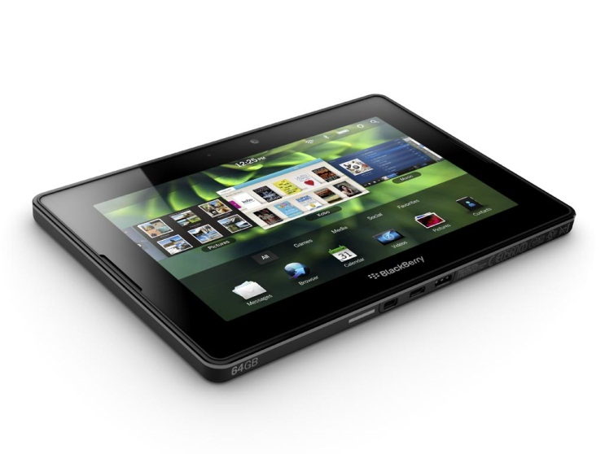
Connect with Wellness Consultant, Whitney Coupland [wcoupland@EWSNetwork.com],
to discuss your results!

