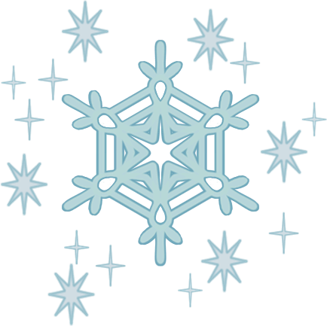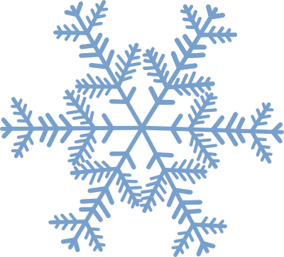

Surviving the Canadian Winter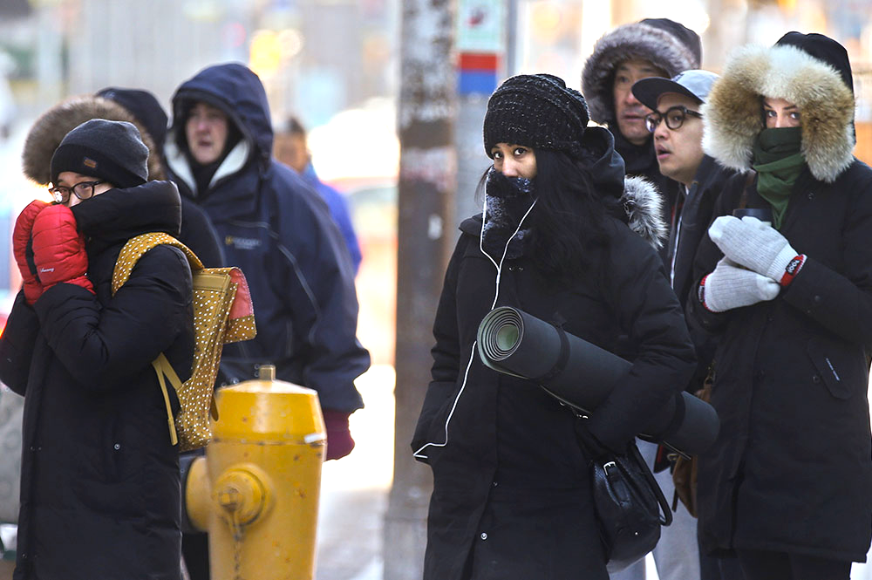

|  |  |
| --- | --- |
| Proper Clothing | ***Bundle up!***  Base Layer   * long sleeve/t-shirt   Mid Layer   * sweater   Outerwear   * Jacket * Waterproof and warm * Best if down-filled * Remember scarf, hat, and mittens! |
| Boots | * Best if lined and waterproof * Make sure the sole has good grip |
| Shovelling | * Stretch before you start shoveling * Shovel early and more often * Push the snow rather than lift * Do not throw snow over your shoulder |
| Eating Right | * Hot foods * Eat lots of vegetables * Eat lean protein sources (beans, chicken, meat, eggs, dairy, nuts & seeds) |
| Emotional Health | Don’t let the weather get you down!!   * Get outside and play * Soak up as much sunshine as you can * Focus on the positive things of winter * Connect with friends |
| Winter Activities | * Running * Skating * Tobogganing * Cross-country skiing   Dress warmly and enjoy the FUN! |
|  |  |

