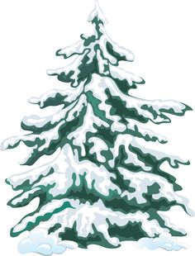

Join us on _________ to learn how to survive the Canadian winter!

You’ve heard how tough our winters could be… so come on out and see how to prepare for this upcoming winter!

(write info on speaker, sign ups)

You **DON’T** want to miss out!

**Winter is coming…**

**Are you prepared?**