***Sept 10 – Dec 03***





Join your coworkers in a 12 week journey to Weight Loss Success! Weekly tips, optional weigh-ins and watch the changes happen.



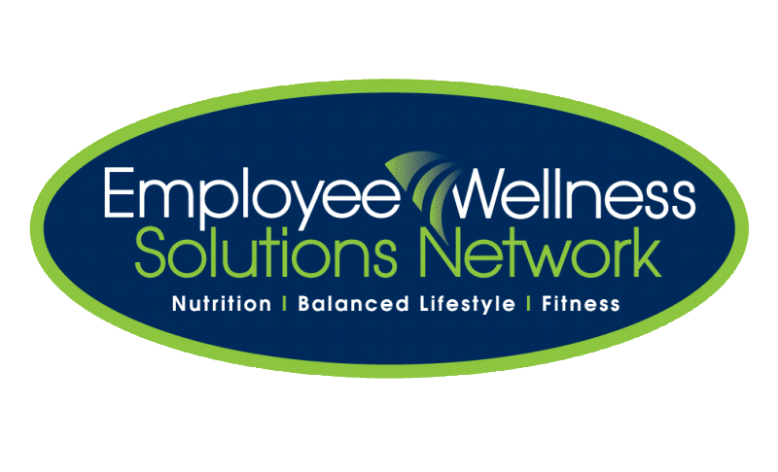

## ©2015 Employee Wellness Solutions Network – All Rights Reserved.



## ©2015 Employee Wellness Solutions Network – All Rights Reserved.

Meet with your Wellness Consultant to choose a healthy, achievable goal.

Determine your fun “alias” so that she can mark your progress on the chart.

**$10 BUY-IN! The winner(s) take the pot!!**