**Salmon Spinach Salad with Warm Mustard Vinaigrette**

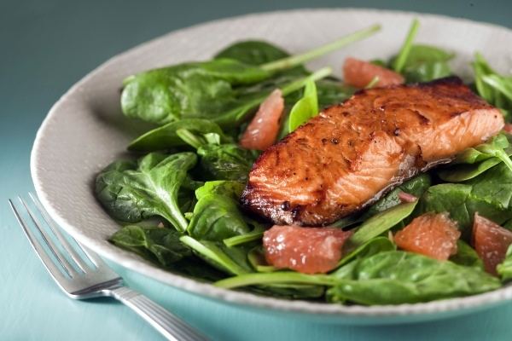**Ingredients**

4 salmon fillets, (about 3 oz/ 90 g each)

½ tsp pepper

¼ tsp salt

3 tbsp extra-virgin olive oil

½ small red onion, thinly sliced

2 tbsp grainy mustad

2 tbsp white wine vinegar

1 pkg (10 oz/284 g) fresh spinach

Any additional desired fruits or vegetables

**Instructions**

1. Season salmon with half each of the pepper and salt. In large skillet, heat 1 tbsp (15 mL) of the oil over medium-high heat; add salmon, skin side down. Cover and fry, turning once, until fish flakes easily when tested, about 12 minutes. Transfer to plate and keep warm. Drain off fat.
2. In same skillet, heat remaining oil over low heat; fry onion until softened, about 3 minutes. Whisk in mustard, vinegar and remaining salt and pepper.
3. In bowl, toss spinach, and additional vegetables/fruit with vinaigrette. Divide among 4 plates; nestle salmon in center.

|  |  |  |  |  |
| --- | --- | --- | --- | --- |
| **Nutritional Information (per serving)** | | | | |
| **Calories** | **241** |  | **Potassium** | **581 mg** |
| **Protein** | **16 g** |  | **Cholesterol** | **37 mg** |
| **Carbohydrate** | **5 g** |  | **Sodium** | **330 mg** |
| **Total Fat** | **18 g** |  | **Fiber** | **2 g** |
| **Saturated Fat** | **3 g** |  | **Makes 4 servings** | |

Resource: <http://www.canadianliving.com/>

**Berry Almond Quick Bread**

**Ingredients**

* 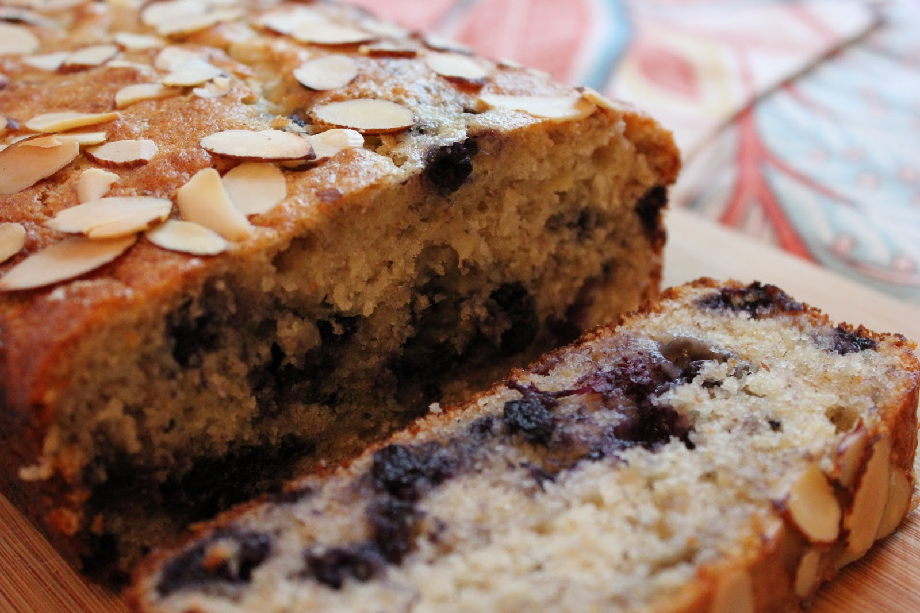 1 ½ cups whole-wheat pastry flour, or whole-wheat flour
* 1 cup all-purpose flour
* 1 ½ tsp baking powder
* 1 tsp ground cinnamon
* ½ tsp baking soda
* ¼ tsp salt
* 2 large eggs
* 1 cup nonfat buttermilk
  + 1. (or mix 1 tbsp lemon juice into 1 cup milk)
* 2/3 cup brown sugar
* 2 tbsp butter, melted
* 2 tbsp canola oil
* 1 tsp vanilla extract
* ½ tsp almond extract (optional)
* 2 cups fresh or frozen berries, (whole blackberries, blueberries)

½ cup chopped toasted sliced almonds, plus more for topping if desired

**Instructions**

1. Preheat oven to 400°F for muffins, mini loaves and mini Bundts or 375°F for a large loaf. Coat pan(s) with cooking spray.
2. Whisk whole-wheat flour, all-purpose flour, baking powder, cinnamon, baking soda and salt in a large bowl.
3. Whisk eggs, buttermilk, brown sugar, butter, oil, vanilla and almond extract in another large bowl until well combined.
4. Make a well in the center of the dry ingredients, pour in the wet ingredients and stir until just combined. Add berries and almonds. Stir just to combine; do not overmix. Transfer batter to the prepared pan(s). Top with additional almonds, if desired.
5. Bake until golden brown and a wooden skewer inserted into the center comes out clean, 22 to 25 minutes for muffins or mini Bundts, 35 minutes for mini loaves, 1 hour 10 minutes for a large loaf. Let cool in the pan(s) for 10 minutes, then turn out onto a wire rack. Let muffins and mini Bundts cool for 5 minutes more, mini loaves for 30 minutes, large loaves for 40 minutes.

|  |  |  |  |  |
| --- | --- | --- | --- | --- |
| **Nutritional Information (per serving)** | | | | |
| **Calories** | **220** |  | **Monounsaturated Fat** | **3 g** |
| **Protein** | **6 g** |  | **Cholesterol** | **41 mg** |
| **Carbohydrate** | **33 g** |  | **Sodium** | **183 mg** |
| **Total Fat** | **7 g** |  | **Fiber** | **3 g** |
| **Saturated Fat** | **2 g** |  | **Makes 12 servings** | |

Resource: <http://www.eatingwell.com/>

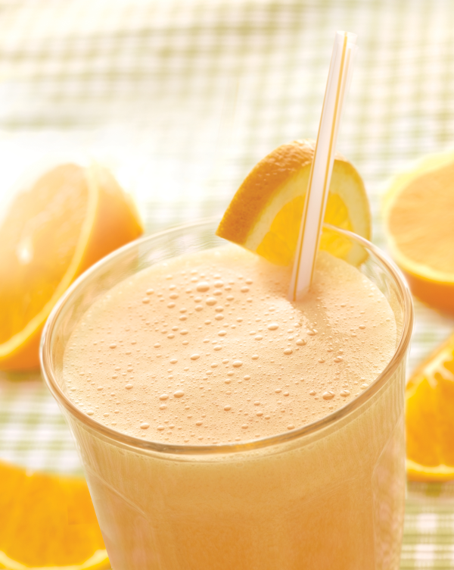

Orange Booster Flax Smoothie

**Ingredients**

* 2 cups frozen peach slices
* 1 cup carrot juice
* 1 cup orange juice
* 2 tbsp ground flaxseed
* 1 tbsp chopped fresh ginger

**Instructions**

1. Combine peaches, carrot juice, orange juice, flaxseed and ginger in blender; blend until smooth. Serve immediately.

|  |  |  |  |  |
| --- | --- | --- | --- | --- |
| **Nutritional Information (per serving)** | | | | |
| **Calories** | **209** |  | **Monounsaturated** | **1 g** |
| **Protein** | **5 g** |  | **Cholesterol** | **0 mg** |
| **Carbohydrate** | **41 g** |  | **Sodium** | **38 mg** |
| **Total Fat** | **4 g** |  | **Fiber** | **6 g** |
| **Saturated Fat** | **0 g** |  | **Makes 2 servings (1 ½ cup each)** | |

Resource: <http://www.eatingwell.com/>