Training for Retirement

Are you close to retiring?

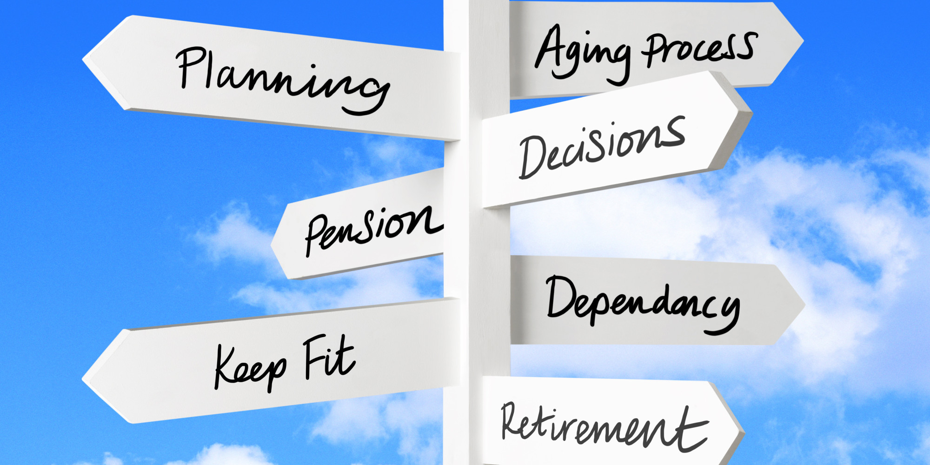Have you ever thought about what it means to ***“retire well”***?

**Sign up for EWSN’s *Training for Retirement* 6-module program to help you retire with strength and vitality!**

Who: Individuals who are less than 5 years from retirement.

When:

Where:

What: Interactive, discussion-based, adult-centered learning.

**Module 1:** The importance of training for retirement.

**Module 2:** Fall prevention

**Module 3:** Healthy Eating

**Module 4:** Physical Activity

**Module 5:** Emotional and Mental Health

**Module 6:** Financial Fitness

|  |  |
| --- | --- |
| **Name** | **Email** |
|  |  |
|  |  |
|  |  |
|  |  |
|  |  |
|  |  |
|  |  |
|  |  |
|  |  |
|  |  |
|  |  |
|  |  |
|  |  |
|  |  |
|  |  |
|  |  |
|  |  |
|  |  |
|  |  |
|  |  |
|  |  |
|  |  |
|  |  |
|  |  |
|  |  |
|  |  |
|  |  |
|  |  |
|  |  |