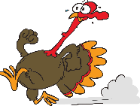

***Chase the Turkey***

***Thanksgiving Pedometer Challenge***

**How many steps can you take in FIVE weeks?**

**Start Date: Monday, September 1st**

**End Date: Friday, October 3rd**

**Walking Cards will be placed in your mailbox with extras at each site. Walk, cross off turkeys, and enter your name**

**for prize draws. The more cards, the more chances to WIN!**

“Walking ranks among the most prevalent and beneficial forms of exercise” (VanWormer, 2004).

“…those who wore a pedometer increased their physical activity by 26.9% and took over 2,000 steps more per day than those who did not wear a pedometer” (Bravata et al., 2007).

**“An estimated 15.4% of Canadian adults accumulate 150 or more minutes of moderate-to-vigorous physical activity in 10-minute bouts per week” (Colley et al., 2011).

**YOUR CHALLENGE: Walk 5,000 steps or 30 minutes per day! For every 1000 steps you take, cross off one turkey on a ballot card.**

**To achieve moderate-vigorous intensity, aim for 1,000 steps in 10 minutes!**

****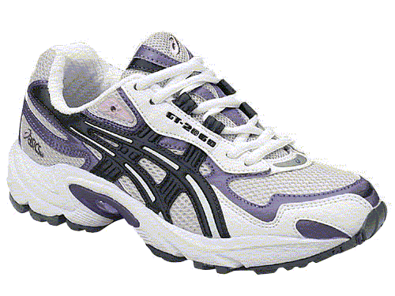

**www.EWSNetwork.com**

**www.EWSNetwork.com**