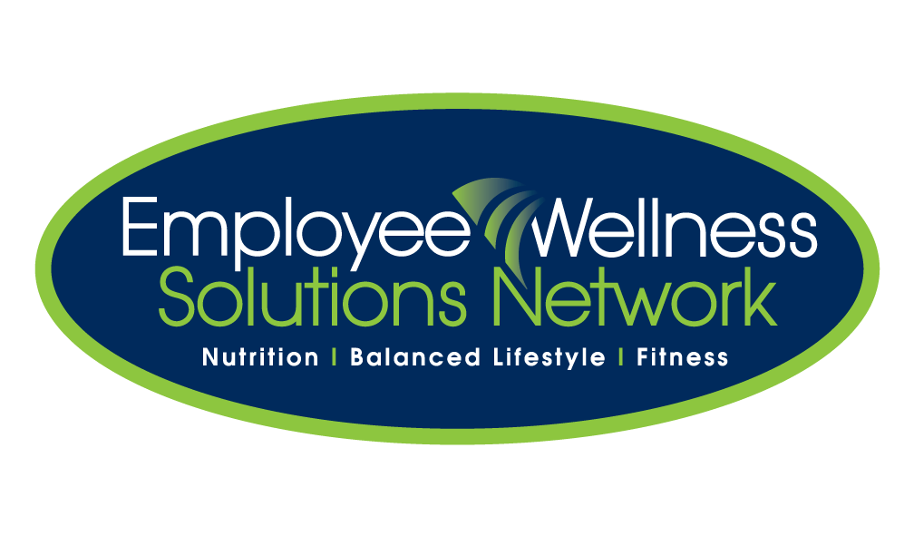

**Workplace Wellness – are you just checking the box?**

By: Garth Jansen, President, Employee Wellness Solutions Network

Canadian companies are getting it – sort of. Most believe in the concept of keeping their employees healthy because it just makes sense. Not only does paying attention to this make a difference in the lives of the people who are the most valuable asset to a company, but there are also many benefits to the bottom line – lowered health claims, improved energy and morale, lowered sickness, and improved productivity.

Typical wellness programs may include conducting an annual health fair, inviting a speaker to do the odd lunch n’ learn, or even providing gym or fitness subsidies. These initiatives are certainly good starting points, but are they worked into the overall objectives of the organization? Will companies really get the biggest bang for their buck? A one-size fits all program/lunch n’ learn/health fair will not have the same effect or return.

A successful, results-based corporate wellness plan needs to offer a variety of programs with the underlying objective of true behaviour change. To have the biggest impact, a comprehensive approach should include focusing on the individual and implementing group and awareness programs suitable to target the widest range of the population. Individual-based programs include personal assessments, tracking and most importantly one-on-one health coaching. Here, the certified health coach works with individuals in achieving personal and/or family wellness goals. This individual component of the wellness plan ensures accountability, follow up and evaluation which contribute to healthy, long lasting behavioural change.

The best way to achieve success with a wellness program is working any chosen initiative into an overall strategy within the organization. The strategic plan should consist of completing a Health Risk Assessment [HRA], establishing a wellness committee, outlining objectives, implementing initiatives and evaluating effort. The results of an HRA outline demographics, employee interests and an overall health risk profile. Strategically aligning the program design to address the results of the HRA, offering programs to support employee interests, and ensuring employee and management objectives are met, all contribute to a healthy return on investment.

Even though ROI is difficult to define [as there are so many factors], by just looking at two typical factors (sick time and health claims costs), a ROI can be realized.

The national average of days off sick in Canada is 7.8 days. Reducing absenteeism by just 1 day/employee/year, is a savings of $17/month/employee [based on 100 employees with average of $50 000 income]. Looking at the average medical claims costs of $1500/employee/year [$125/month], and by lowering that by just 5%, there is a savings of $6.25/employee/month. By just measuring these two factors, is a savings of $23-$24/employee/month. If the cost of a comprehensive program was $10/employee/month, that’s already a ROI of 2.4:1! This isn’t even taking into consideration other factors [morale, energy, physical health, WSIB claims, return to work, retention/attraction costs].

The employee wellness industry is growing because it’s easy to see a return on better health. The more programs offered to encourage lasting behaviour change, the healthier the return will be. Healthy employees cost less. Period.

Employee Wellness Solutions Network [EWSNetwork] is a corporate wellness program provider who helps organizations understand their wellness objectives, how to have the most impact on achieving these objectives through strategic wellness program design, and evaluating the chosen initiatives to ensure goals are met.

**Contact EWSNetwork today to make your wellness initiative more than just a "checkmark". Learn how to make it work within your strategic plan. Email us at info@EWSNetwork.com or call us at 519.860.0502.**

**www.EWSNetwork.com**