Employee Wellness

Employee Wellness Solutions Network (EWSNetwork) is an industry leader when it comes to corporate wellness. Since their inception in 2003 they have grown to service organizations in over 50 different cities. Currently, EWSNetwork services corporate clients in four Canadian Provinces and in two USA States with plans for continued growth.

EWSNetwork has the expertise and proven results-based system to service corporate clients ranging in size from less than 50 employees to over 1000. For each client, they maintain the highest quality of service and take pride in their ability to create individualized, successful programming for each organization.

Their clients come from a full spectrum of industries that include Financial Services, Automotive Manufacturing, Public Utility, Telecommunications, Office and Shipping, Insurance, Car Dealerships, Social Services, Warehouse, Law Firms, Banking, Education, Engineering, Construction and others.

They have a servicing network of over 25 wellness consultant professionals with many other strategic alliances in different communities that support their various programs. The unique system of recruiting, training and supporting the wellness professionals assures quality control.

EWSNetwork designs each customized corporate wellness program with three main components: Individual, Group and Awareness. Their main focus is working with employees through lasting behaviour modification wellness initiatives. The unique and proprietary programs and systems engage employees from all levels of healthy behavioural change.

Strategically aligning the wellness program design to address the results of a health risk assessment [HRA], offering programs to support employee interests, and ensuring employee and management objectives are met, all contribute to a healthy return on investment.

Working together to bridge the gap
between benefits and wellness
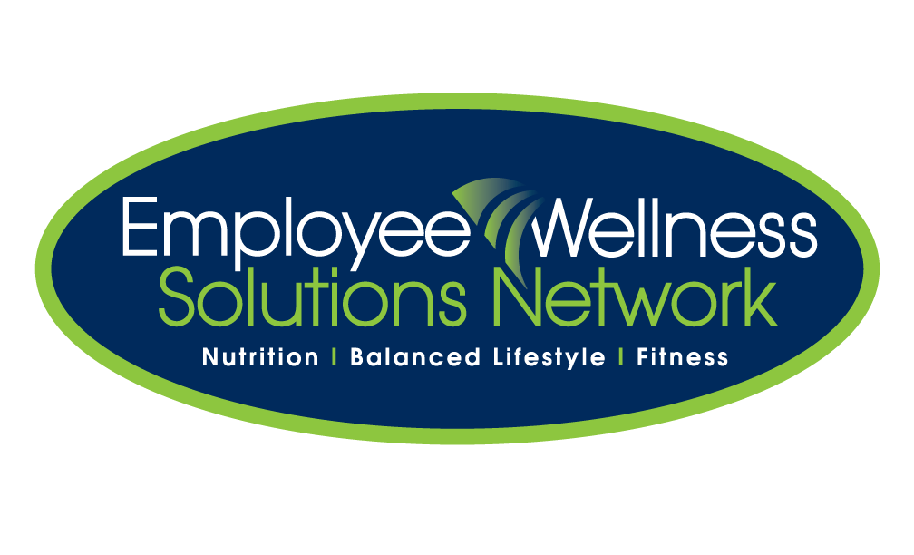


Customized wellness programs
to meet your company’s needs and interests.

Employee Wellness Solutions Network works diligently to provide unique program designs that target the needs and interests of any organization. Our focus is on taking programming, information and initiatives directly to the employees, thereby maximizing participation. This unique approach ensures that your wellness program is reaching not only the people who are already interested in health, but also the people who need a wellness program the most.

Employee Wellness Solutions Network designs its wellness programs on four very important and necessary components for a successful wellness program. Combining all four of these components draws the largest employee engagement. Our approach addresses individual needs, establishes a healthy group culture, and enhances awareness across the workforce. Even for those with smaller satellite locations, our virtual programming ensures that there is truly something for everybody.

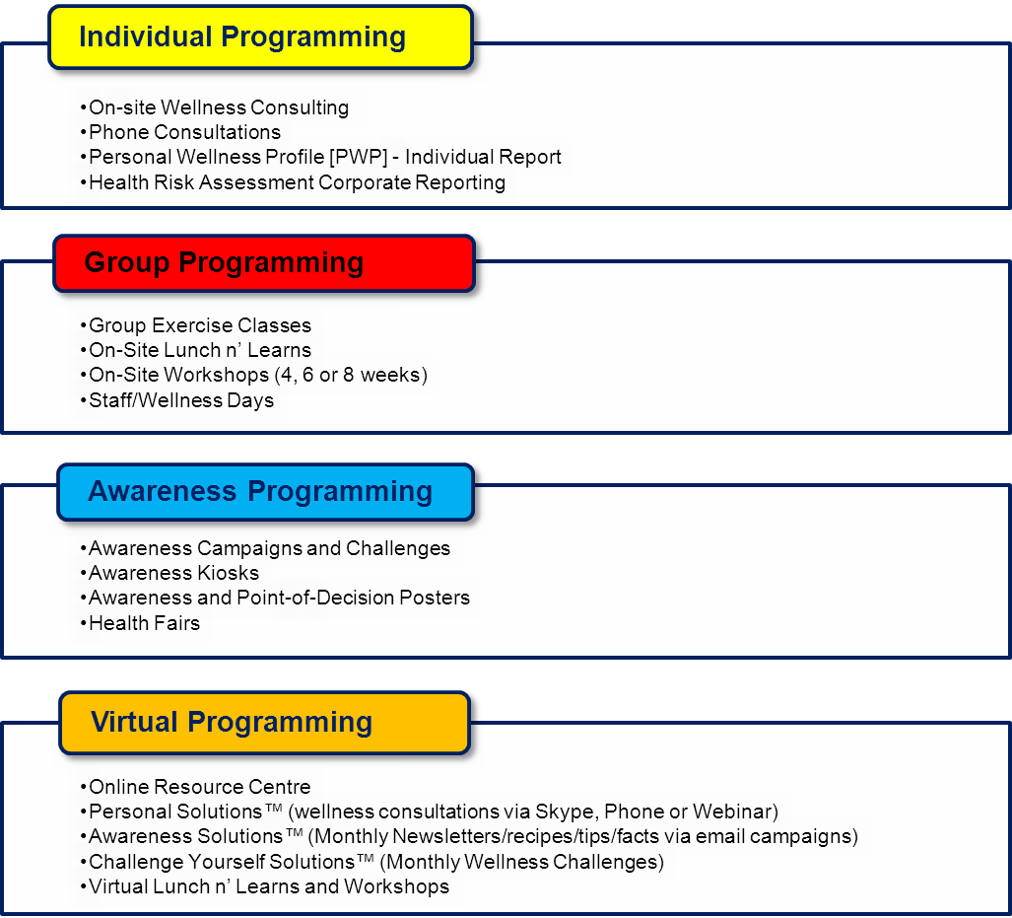


Working with EWSNetwork is about more than just ensuring your staff have access to knowledge and personalized supports that encourage them to live more healthy lives – it’s also about team building and showing that you care as an employer. In working with EWSNetwork I have been impressed at the time they have taken to understand our organization and our staff, and to customize an approach that truly met the needs of our employees in various locations. The result of this thoughtful planning is that over 70% of our employees are engaged in the program, health benefit costs have been kept stable, and most importantly, our staff know each other better.
- Peter Frampton, Executive Director, Learning Enrichment Foundation

Taking a proactive approach to wellness, EWSNetwork is assisting Libro staff to take charge and work towards a healthy lifestyle. Partnering with EWSNetwork in January of 2013, we have a participation rate of over 80% of our company and the excitement of this program is continuing to spread.
One-on-one wellness consultations allows staff the opportunity to speak on topics they choose, in a safe and confidential environment. The wellness consultants have done a great job in providing staff with creditable information and tools to move forward with their wellness goals.
The proactive approach to healthy living is what Garth, Meaghan and the great team at EWSNetwork promote each and every day to over 250 staff at Libro!
- Theresa Mikula, VP Human Resources, Libro Financial Group

Prior to introducing wellness solutions to our customers, we wanted to "test drive" a full EWSNetwork wellness program with our staff. We introduced the program 3 years ago and the results speak for themselves:
- Our health and drug claims were reduced by 42% first year and 17% year 2. as a result our benefits costs have decreased.
- Our employee absenteeism went from an average of 5 days per year down to 1.
More importantly, our staff viewed it as a great benefit and all our eating much healthier, participating in various areas of fitness and also bringing the changes home to their families so they are healthier as well.
After having such great results, we have been actively introducing it to our customers and the ones that have implemented it have had similar results!
- Kevin Brady, President, Brady Financial Group

Farnell Packaging has recently embarked on a wonderful new partnership with the team at EWSNetwork. They are caring, knowledgeable and down-to-earth professionals who are bringing a wealth of valuable information and on-site resources into our workplace. We are already receiving very positive feedback from staff who are benefiting from the personal wellness consultations and feeling they have access to the support and information that will lead them towards success in their wellness goals. We have a strong belief that this investment in our staff will have excellent short-term and long-term benefits.
- Judy Farnell, President, Farnell Packaging


We have had a partnership with Employee Wellness Solutions Network (EWSNetwork) for over 5 years. They have been instrumental in establishing our employee wellness program and in facilitating our in-house employee committee. The tools available to our staff through their online web site as well as through personal one-to-one individualized consulting have been well received by our staff and assisted them with reaching their personal wellness goals. Their creative and professional team provides many ways of educating our staff on wellness and healthy living options. Our employee participation rate is good and changes for the varied exercise programs. EWSNetwork have implemented departmental fitness challenges that have benefited our staff morale as well as provided a healthy work environment. Our staff look forward to every event, whatever it may be.
- Grant Wren, Human Resources Manager, Amway Global Canada

