

Join us for two weeks and improve your health, save money and help reduce environmental damage!

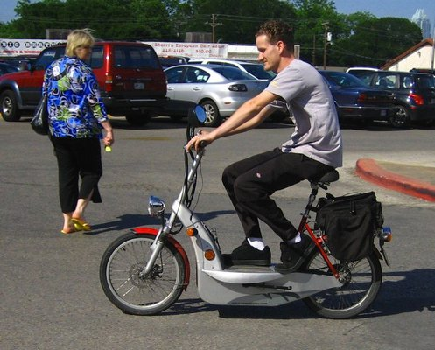****

* You walk, cycle, carpool, take transit or any other form of healthy, sustainable transportation during the two-week challenge period.
* To be included in the challenge, you must make *at least* one sustainable commute during the challenge, but we encourage you to try and do this as many days as possible!
* Track your daily kilometres travelled in the method of your choice on the provided Excel spreadsheet.
* As the days go by, you will be able to see how your efforts impact emission reduction, calories burned and fuel cost savings.
* At the end of each week, fill out a ballot with your total kilometres swapped from driving to work alone to another sustainable method and be entered into a random draw to win a prize at the end of each week.
* The grand prize winners will be announced at the end of the challenge and will also be rewarded with a prize! The winner will be the participant who was the most consistent in making changes to the way they commute to work. If there is a tie, the winner will be determined by who burned the most calories in making their swaps.

***How It Works:***

Start Date: <date>

End Date: <date>

FOR QUESTIONS AND FURTHER INFORMATION:

Contact: <EWSNetwork consultant>

Email: <name@ewsnetwork.com>