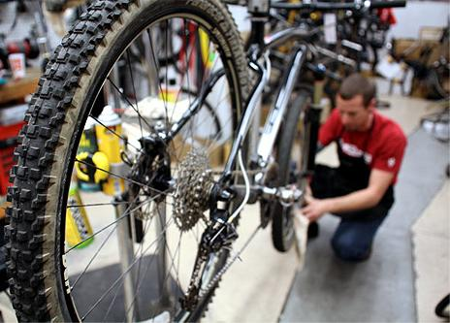

Would you like to participate in this challenge by riding your bike to work?

Has it been awhile since you’ve taken it out of the garage and dusted it off?

Safety and comfort are crucial when riding your bicycle which is why EWSNetwork has arranged to have a bicycle repair expert attend your location to do assessments on bicycles for those who are interested.

They will assess your bicycle and provide tips for maintenance you can do on your own and make recommendations for repairs or upgrades that may benefit the functionality of your bike!

The assessments will take place on <Date> between the hours of <0:00-0:00>.

If you are interested in having your bicycle assessed, please register on the sign-up sheet and bring your bike to work on that date.

Feel free to contact <name> of EWSNetwork at [name@ewsnetwork.com](mailto:name@ewsnetwork.com) with any questions you may have about this special event!

Free Bike Assessments!