

Let’s face it – snacking doesn’t have the best reputation. That’s not because eating between meals is necessarily bad for you, it’s because people tend to choose foods that are full of salt, sugar & fat when they get hungry between meals.

Think of healthy snacking as another way to help you get all the nutrients you need to stay healthy and energized. Eating every 3-4 hours also helps to keep your blood sugar levels stable throughout the day and can keep you from getting too hungry and overeating at your next meal.

Over the next two weeks, we are challenging you to **only** consume healthy foods at snack time! We will have some helpful snack ideas for you, either posted on-site or sent via email. You will also receive a log sheet where you can indicate what time you ate your snack, what you ate, whether your snack included both a healthy carbohydrate and a healthy protein source and track that you included a glass of water with your snack.

We want you to learn how to incorporate healthy snacking into your daily life – here are some guidelines to get you started -

**Healthy Snacking Challenge**

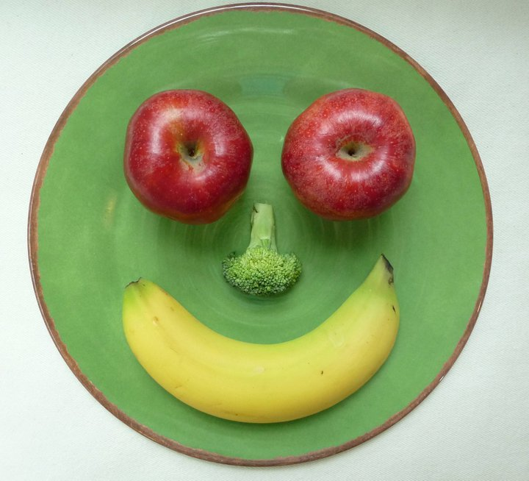****

*Source:* [*www.webmd.com*](http://www.webmd.com)*, healthland.time.com*

* Choose the foods you snack on wisely – you should be choosing whole foods and avoiding most pre-packaged, processed foods as they tend to be full of fat, salt, sugar & preservatives while being low in nutritional value.
* Watch portion sizes! The ideal snack comes in under 200 calories – don’t get a snack confused with a meal!
* Snack when you are hungry and avoid mindless eating as it can have a great impact on your daily caloric intake and lead to unwanted weight gain.
* Preparation is key! Make your own healthy snack pack to bring with you to work – this will help you avoid the temptations that can lie within the work vending machine.
* Drink water with your snack – many people just don’t get enough water throughout the day. If you make the effort to drink a glass with your snack, it will help you feel full and stay hydrated.
* Limit your snacks to no more than 3 per day – ideally, you are looking to eat a snack mid-morning, one between lunch and dinner and (if necessary) one small snack in the evening.



Sources: [www.dietitians.ca](http://www.dietitians.ca)

