*** KICK IT: A Guide to Smoking Cessation in the Workplace***

**Weight Maintenance Fact Sheet**

**3 THINGS.**

* + When you quit smoking, your body needs to get rid of the poisons left in it by cigarettes. Your body will clean and heal itself faster if you eat well and drink at least six glasses of water per day.
  + A car runs on gas. People run on food. Neither runs properly on too much cola or coffee.
  + If you choose a physical activity you enjoy, you’re more likely to stay with it.

**Frequently Asked Questions**

* 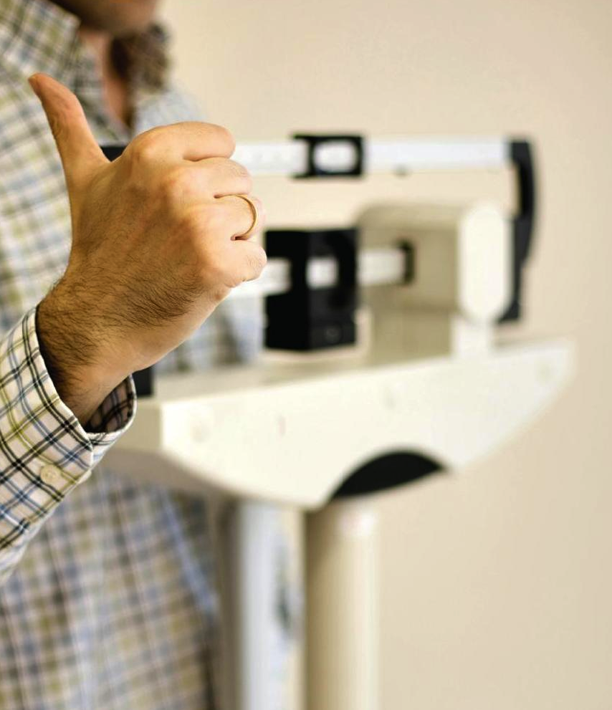**Will I automatically gain weight when I quit smoking?**

Many, but not all gain weight when they quit smoking. Many quitters do gain between five and ten pounds when they quit smoking. However, many cigarette smokers also weigh less than others who are of the same height.

* **If I quit smoking and gain weight, have I traded one health problem for another?**

No. Weight gain is a much smaller health hazard than smoking. You would have to gain 125 pounds to equal the dangers of a pack-a-day addiction.

* **Should I worry about gaining weight while I’m trying to quit?**

No. For most people, quitting smoking takes serious effort and concentration. Worrying about weight gain can split your attention and make it more difficult. It may be easier to focus on one thing at a time.

* **Can I quit and not gain weight?**

Yes. Eating healthily can be a great substitute for smoking. Eating well can help reduce or avoid weight gain and help you to feel good.

* **While you’re quitting smoking, remember:**

You are achieving a very important goal, even if you do gain weight. It’s easier to work on one thing at a time. There are physical reasons why you may gain weight. It is not just a lack of willpower. Weight gain does not have to be permanent.

Source: [www.cpha.ca](http://www.cpha.ca)