*** KICK IT: A Guide to Smoking Cessation in the Workplace***

**Slips**

What is a Slip?

Research shows that **a slip is the #1 thing that leads back to regular smoking**. Even one puff can re-program your brain to demand more nicotine.

A slip is when you have a cigarette or two after you have quit smoking. This does not mean you have failed. Think of it like a fire alarm – when the alarm rings, you need to know exactly what to do, what to say, where to go, and whom to ask for help. Plan ahead the same way as you would for a fire drill.

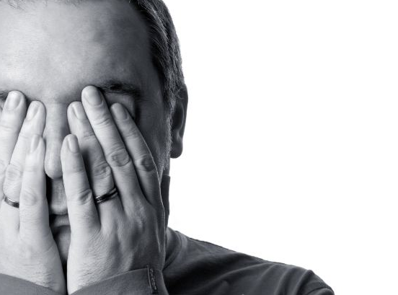

Change the Situation.

* Stop smoking immediately.
* Leave the room or situation.
* If you bought cigarettes, throw them out.

Talk Positively to Yourself.

* Remind yourself how far you have come, not just how far you have to go.
* Encourage yourself not to give up!

Take Action.

* Do something that makes it impossible to smoke (take a shower).
* Find a bigger focus than cigarettes or the craving (focus on gardening, work, the news, do something active with your kids).
* Do not criticize yourself.
* Make your mouth and throat feel differently (chew mint-flavoured gum).
* Do something active – go for a brisk walk outside. Fresh air clears your head.
* If you’re having a major craving, sit down and breathe deeply until the feeling passes.

Ask for Help.

* Talk to someone to distract or encourage you.

If you slip, don’t worry about it! **It does NOT mean you have to just give up**. Keep your chin up and keep working on it. Try to figure out why it happened and make plans to avoid it in the future.

Source: <http://www.gosmokefree.gc.ca>