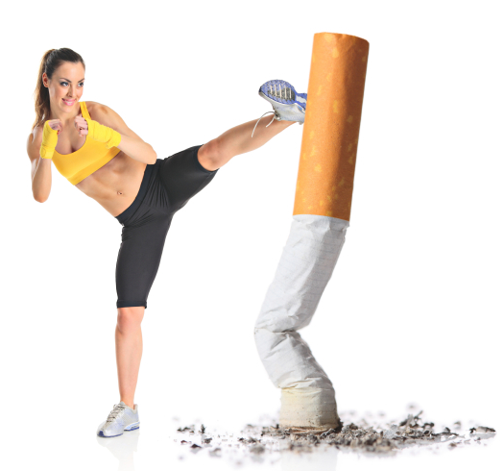 ***KICK IT: A Guide to Smoking Cessation in the Workplace***

**Tips for Being Active**

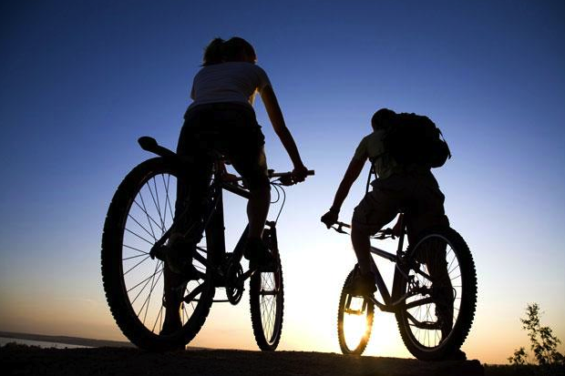

By stopping smoking, staying at a healthy weight, eating well and getting enough physical activity, you are helping your body fight against heart disease, cancer, diabetes and other illnesses. You aren’t just helping your physical body but also improving your relationship with others and with yourself!

Being Active At Home

* Start your day with 10 minutes of movement indoors or outdoors (ex. stretching or short walk, push ups, sit ups, running up and down the stairs).
* Go for a bike ride.
* Trade in your power mower for a push mower.
* Park your car further from your destination.
* Parents – play catch or fly a kite with your kids
* Dance to your favourite up-beat music for 10 minutes a day. Dance like no one’s watching to whatever tunes makes you move!

Being Active At Work

* Take standing breaks every hour or two (set an alarm to remind you).
* Take stretch breaks.
* Take the stairs. Pretend the elevator is out of service.
* Contract your stomach and back muscles while standing or sitting.
* Go for a walk during lunch time with a colleague or alone.
* Roll your shoulders and stretch your neck often.
* Replace an exercise ball with an office chair.

Being Active in Transportation

* Walk, cycle to work or school.
* Get off the bus two stops early.
* Take your bike. You’ll save on gas as well as protect the environment and your health.
* Make a personal or family commitment to try a new activity each season: snowshoe, curl, hike, bike, dance, bowl, fish, camp, ice-skate, ski, snowboard, swim, walk, run, skip rope, cross-fit, play tag or play ball with your kids.

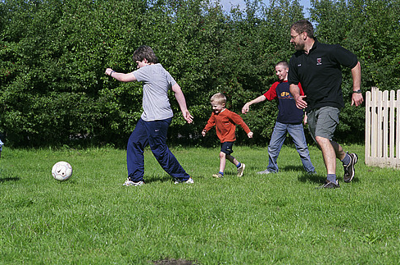Other Activities

* Garden, rake, weed.
* Explore your neighbourhood with your spouse or kids! See how many 10 minute walking or cycling routes you can find.
* Play tennis.
* Arrange to meet a couple of friends for a walk on the same day at the same time.
* Join a Tai Chi or yoga class or other classes at a local community centre.
* Go line dancing, folk dancing, or square dancing.

Source: [www.cpha.ca](http://www.cpha.ca)