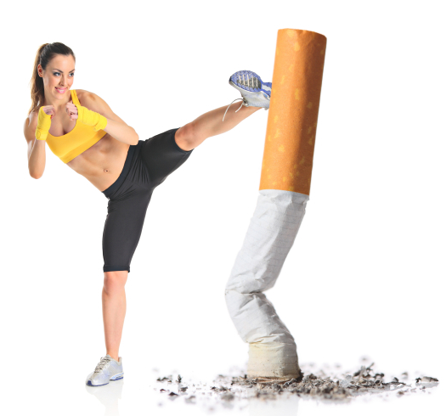 ***KICK IT: A Guide to Smoking Cessation in the Workplace***

**Fat: Not This, But That.**

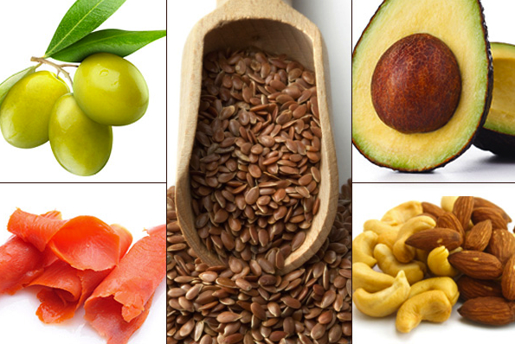

According to Canada’s Food Guide, less than 30% of our calories should come from fat.

Some fats include: butter, margarine, oil, mayonnaise/miracle whip, ice cream, sour cream, cream, salad dressing, gravy, dips.

If you typically eat or cook with the first column, try replacing it with the second column!

|  |  |
| --- | --- |
| Not this: | But that: |
| Fried meat | Broiled meat with fat trimmed before cooking |
| Chicken with skin | Chicken with skin and fat trimmed off before cooking, with herbs, spices and a little BBQ sauce |
| Whole milk | 2%, 1%, or skim milk |
| Cream sauce | Sauce prepared with herbs and spices or with 2%, 1%, or skim milk instead of cream |
| Cream soup | Soup creamed in the blender with 2% milk instead of cream |
| Creamed cottage cheese | Low-fat cottage cheese (2% milk fat (m.f.) or less) |
| 4 strips of bacon | 2 strips of bacon or peameal bacon (“back bacon”) blotted out with paper towel after cooked |
| Bologna, salami | Leftover meat, tuna, salmon, turkey slices, roast beef |
| Fried egg | Boiled or poached egg |
| Piece of cheddar cheese | Piece of mozzarella cheese (reduced fat) or other cheese with fat content of 15% m.f. or less |
| French fries | Baked, boiled, or mashed potatoes |
| Fruit-bottom yogurt | Low-fat yogurt (2% m.f. or less), low-fat Greek yogurt, or low-fat plain yogurt with your choice of fresh fruit and a little bit of honey |
| Doughnut | Sliced whole wheat bread, graham crackers, melba toast, homemade muffin |
| Chips | Pretzels, plain popped corn, nuts (almonds, walnuts) |
| Ice Cream | Frozen yogurt |
| Store-bought muffins | Homemade muffins replacing butter/oil with applesauce or mashed bananas |
| Mayonnaise | Mustard (Dijon, honey), avocado slices |
| Marbled Red Meat | Salmon, chicken breast, extra lean or lean ground beef/turkey/chicken/pork |
| Caesar or ranch dressing | Olive oil based vinaigrette (balsamic, Greek) |

Source: [www.cpha.ca](http://www.cpha.ca)