*** KICK IT: A Guide to Smoking Cessation in the Workplace***

**Slim Snack List**

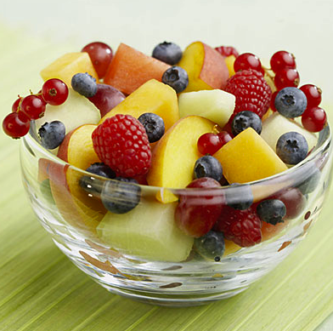

**Tips**

* Slowly ease off coffee and alcohol. Replace it with low-fat milk or pure fruit or vegetable juice but not pop.
* Choose water (0 calories!). Try drinking one glass before a meal, at mid-morning, at mid-morning, and before going to bed.
* Eat 5 smaller meals each day.
* Increase fibre (whole grain cereal, bread, rice, pasta). This will make you feel full, helping you eat less. Ex. legumes (peas, beans, lentils), fruits, veggies, nuts, seeds.
* Plan meals. Try creating a weekly menu.
* Make meals attractive (use different colours and textures). Use a smaller plate rather than a large one.

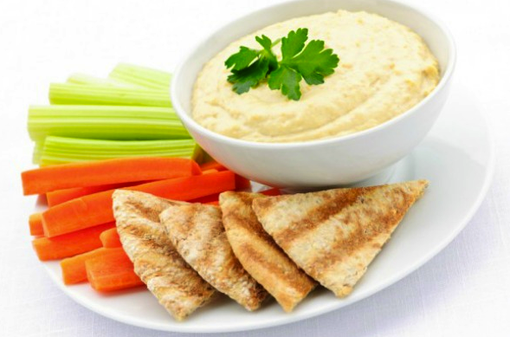Select or circle foods that you would eat each day. These are all healthy choices!

|  |  |
| --- | --- |
| Fresh fruit | Fresh vegetables (carrots, celery, cucumber, cauliflower, broccoli, green peppers, tomatoes, etc) |
| Low-calorie dip | Celery stalks with small amounts of peanut butter [1 tbsp] |
| Melba toast | Popcorn (unbuttered) |
| Low-fat cheese and crackers | Sugar-free mints |
| Raisin, prunes, apricots, figs, peaches (BUT dried fruit is higher in calories than fresh) | Nutty banana – 1” banana slices covered with crushed nuts, cereal, or peanut butter |
| Frozen grapes (they taste like a popsicle) | Homemade muffin (cut the fat and sugar in half) |
| Low-fat yogurt | Whole-grain cereal |
| Fresh fruit salad | Fruit shake with skim milk and variety of frozen fruits |
| Peanuts in the shell | Dry roasted, unsalted nuts (only a handful per day) |
| Hummus and whole wheat pita | Unsalted sunflower seeds |
| Crunchy bell peppers, sliced | Snow peas |

Source: [www.cpha.ca](http://www.cpha.ca)