*** KICK IT: A Guide to Smoking Cessation in the Workplace***

**Stretching Exercises**

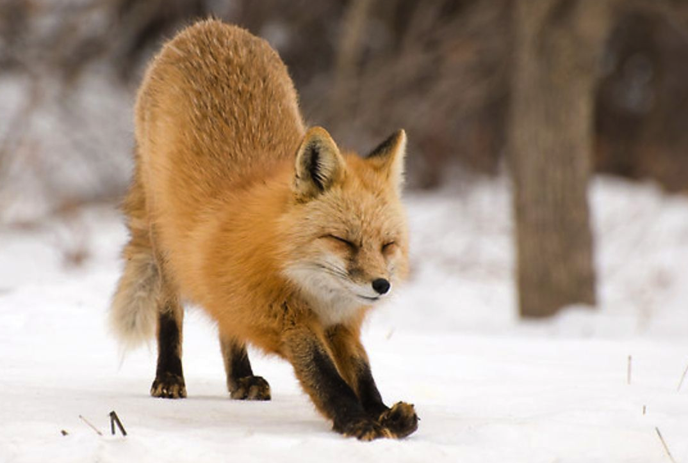

Try these stretching exercises every day, every other day, or make it your weekend routine! Remember to stop a stretch just before pain starts. Try some or do it all. Have fun with it as you release your stress away.

* **Shoulder shrugging** 5x.
* **Shoulder rotating** backward 5x.
* **Shoulder rotating** forward 5x.
* **Elbowing:** raise elbows to shoulder height with hands hung down loosely. Clench fists and move elbows backward energetically. Use sentences like “get off my back.” Repeat 5x.
* **Arm flinging:** Place palms of hands on chest with elbows raised out to the side. Fling arms gently outward and backward, unbending elbows. Do each arm 5x alternating with right and left arm. Use your head and eyes to follow your swinging arms.
* **Pushing arms forward:** place hands in front of chest, palms facing out. Push irritating or hurtful situations away. Use phrases like, “get away.” Repeat 5x.
* **Jumping and shaking:** jump up and down on your toes, keeping knees loose. Move shoulders, arms, head. The idea is to loosen the whole body by shaking it up. Shake tension out of fingertips, and toes.
* **Head rotation:** do these circles forward only. Drop head forward. Rotate right, centre, left, back to centre. Repeat 5x.
* **Reaching/stretching:** First with 1 hand and then the other, reach above your head as high as you can. Imagine grabbing hold of a rope and pulling it down 5x for each arm, alternating with right and left arm.
* **Stomping with hands and feet:** lie on your back on the floor, knees bent, head on floor, hands and feet on ground. Hit floor with palms and stomp feet (looks like temper tantrum). Make noise or say, “no,” “stop,” “don’t.”

Source: [www.cpha.ca](http://www.cpha.ca)