*** KICK IT: A Guide to Smoking Cessation in the Workplace***

**Why are we here? Why should I quit?**

When you start to lose focus about, “why am I here?” or “why should I quit?” refer to this sheet!

|  |  |
| --- | --- |
| 20 minutes after quitting | Blood pressure drops to your pre-cigarette level |
| 8 hours after quitting | Carbon monoxide in your blood drops to normal and oxygen in your blood increases to normal |
| 24 hours after quitting | Lowered chances of having a heart attack |
| 48 hours after quitting | Sense of smell and taste improve and begin to return to normal |

Quitters *immediately* begin to reduce the risks of developing heart disease, cancer, and breathing problems. Former smokers live longer than those who continue to smoke!

**Within 24 hours of quitting…**

**In the months and years to come…**

|  |  |
| --- | --- |
| 2 weeks – 3 months after quitting | Circulation improves and your lungs work better |
| 9 months after quitting | Less coughing, sinus congestion, fatigue and shortness of breath |
| 1 year after quitting | Reduce risk of heart disease by half! |
| 5 years after quitting | Risk of stroke is greatly reduced. After 5 – 15 years after quitting, your risk is about the same as a non-smoker’s risk |
| 10 years after quitting | Reduce risk of dying from lung cancer by half! Risk of cancer of the mouth, throat, esophagus, bladder, kidney, and pancreas also decreases. |
| 15 years after quitting | Risk of heart disease is about the same as a non-smoker |

**Over half the people who have ever smoked in Canada have quit.**

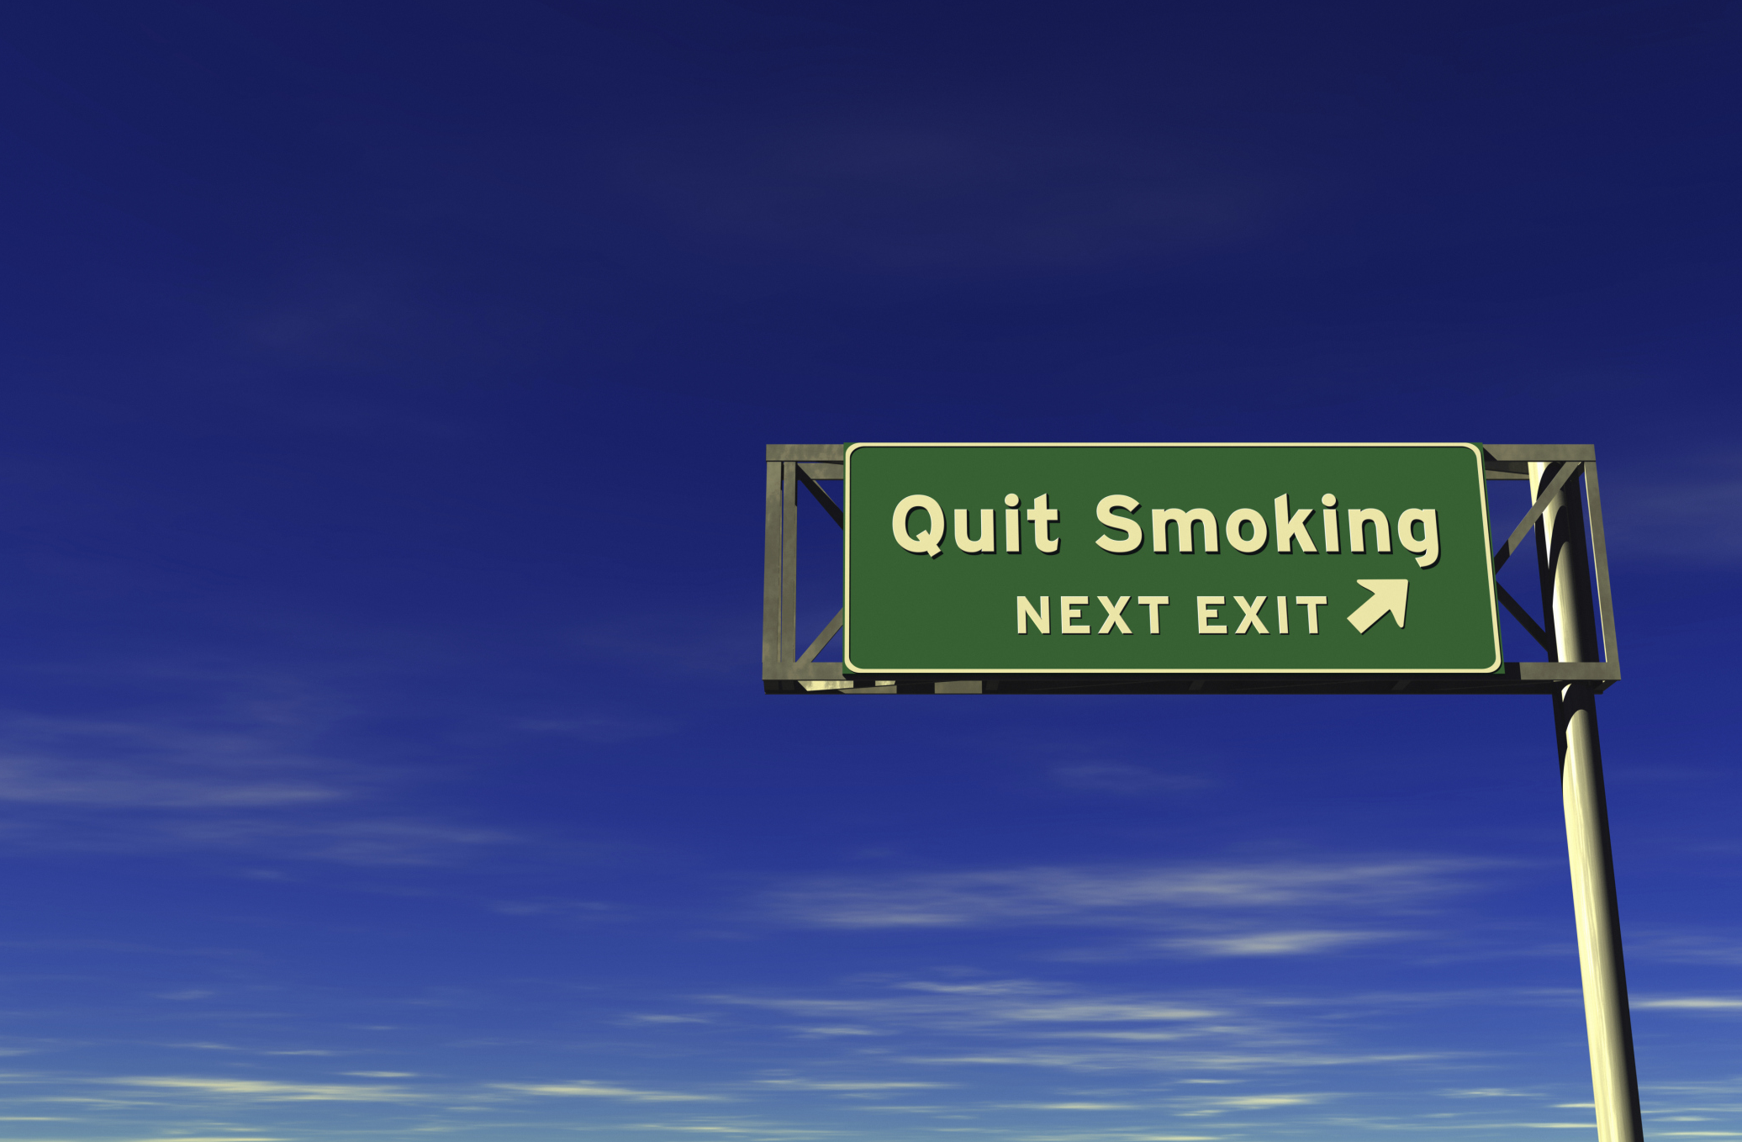**YOU CAN TOO!**

Resource: [www.gosmokefree.gc.ca](http://www.gosmokefree.gc.ca)