*** KICK IT: A Guide to Smoking Cessation in the Workplace***

**What is Stress?**

Stress *itself* is not a problem!

* Stress is a natural part of living. It is only a problem when there is no break from it in which you can become mentally and/or physical sick.
* 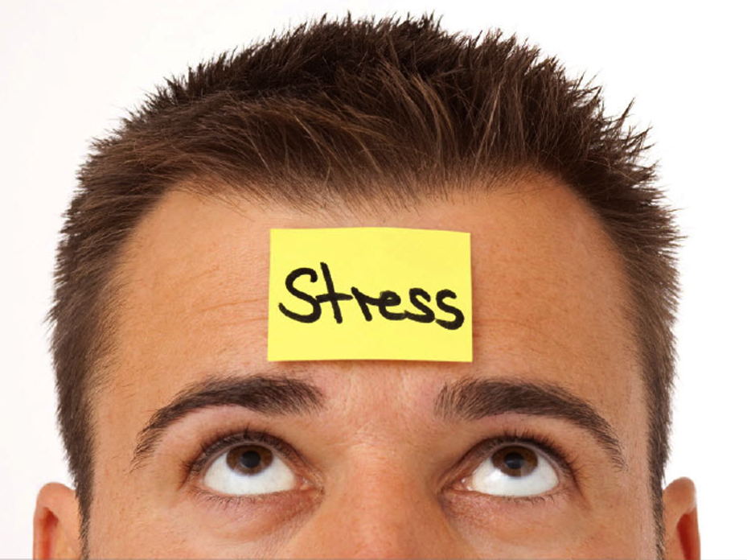Stress can be caused by something happening to you, or by thinking certain thoughts, but it happens to your body.
* Stress overload signs may include:
  + Muscle tension
  + Headaches
  + Concentration problems
  + Sleep problems
  + Appetite changes (weight gain or loss)
  + Change in activity level (nervousness or lack of energy)
  + Susceptibility to colds and viruses
  + Pounding heart, high pulse rate, change in breathing

Stress Release

Sometimes the fastest and easiest way to relieve stress is by focusing directly on the body.

* **Take good care of your body.** 
  + ****Eat healthy, regular meals
  + Use regular exercise to let off steam
  + Cut down on caffeine, alcohol, and drugs.
* **Make “me time” every day.**
  + Even if it’s only 5 minutes a day, take them and enjoy them!
  + Listen to calm music, have a bath, go for a walk.
* **Don’t expect too much of yourself.** 
  + Give yourself time to adjust.
  + Remember that you’re only human!
* **Get help and support when you have a problem.** 
  + Talk with a friend or counselor immediately when you have a problem – do not wait.

**3 THINGS.**

1. Smoking does *not* help you relax – It’s something you’re used to doing when you take a break.
2. The average weight gain from quitting is ~5-6 lbs. Healthy eating and active living will help you shed those pounds once you’re feeling good about yourself as a non-smoker.
3. Your friendships do not depend on smoking. There’s much more to true friendship than that! Plus, your self-confidence will improve when you quit smoking.

Source: [www.gosmokefree.gc.ca](http://www.gosmokefree.gc.ca), [www.cpha.ca](http://www.cpha.ca)