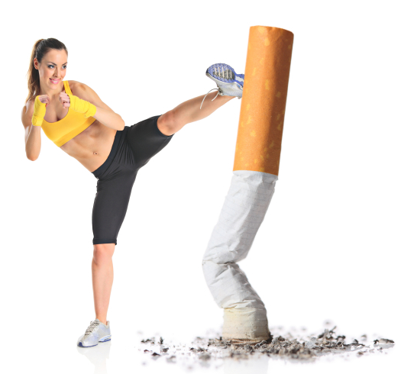
KICK IT: A Guide to Smoking Cessation in the Workplace
Deep Breathing

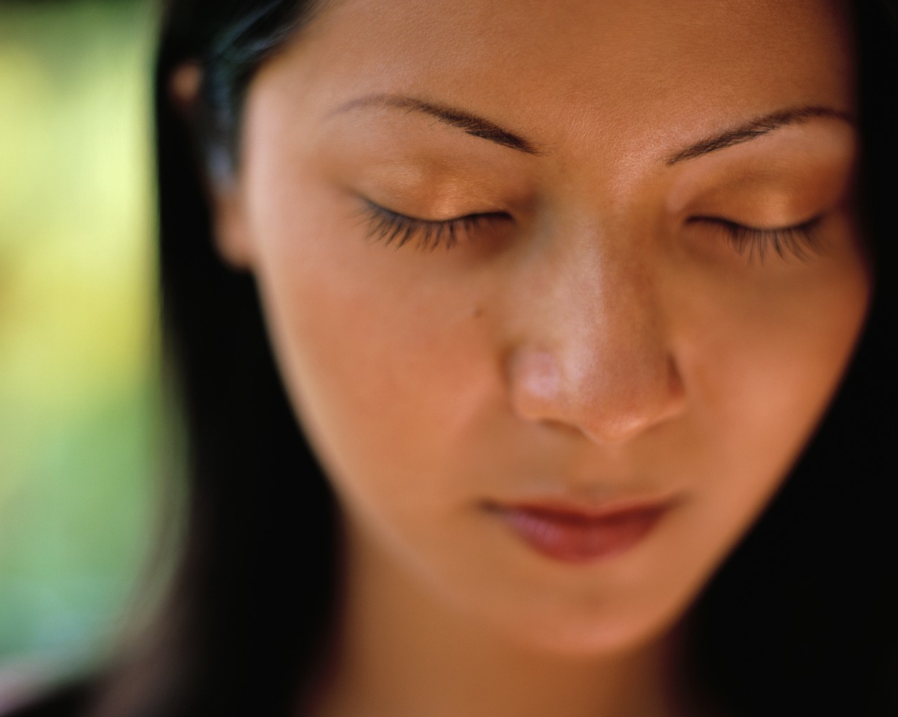
General Instructions
- Be gentle. Never strain.
- Wait at least ONE hour after eating.
- Sit in a comfortable position with your back straight,
- Practice for about 10 minutes in one sitting. You may practice 3 times a day.
- Play peaceful music if you like.
- Don’t try to cover all of these in one session.
- The Basic
- Close your eyes (optional).
- Take a deep breath in through your nose and hold it for a count of five.
- Push out your stomach at the same time. This makes the air go deeper into your lungs. Slowly breathe our through your mouth to the count of seven.
- Repeat this three times interspersed throughout the day.

- The Complete Breath
This kind of deep breathing brings air deep into your lungs and more oxygen into your bloodstream. You will be using your diaphragm (muscle underneath your lungs).
- Lie down on our back on a mat or rug with one hand on the centre of your chest and the other on the bottom of your rib cage.
- Breathe in slowly and deeply through your nose. Push out your abdomen to fill the lower part of your lungs.
- Expand your chest more and fill the top of your lungs. Hold your breath for a few seconds. Breathe out slowly until your have emptied your lungs. Repeat this four or five times interspersed throughout the day.


- Breathing Relaxation
This kind of deep breathing gives energy and a sense of calm. You can use visualization or can be used as a relaxation exercise.
- Sit where you’re comfortable and your spine is straight but not rigid. Close your eyes if desired.
- Think about the times you have felt calm and at peace (ex. went for a quiet, slow walk by a river or through a river).
- Concentrate on your breathing. As you breathe in, bring energy and peace in with you; as you breathe out, let your tension and worry float away. Do this slowly several times.

- Breathe into your feet. As you exhale, feel you ankles relax.
Breathe into your thighs. As you exhale, feel your thighs relax completely.
Breathe into your buttocks. As you exhale, feel your buttocks relax.
Breathe into your belly. As you exhale, feel your belly relax.
Breathe into your back. As you exhale, feel your back relax.
Breathe into your chest. As you exhale, feel your chest relax.
Breathe into your shoulders. As you exhale, feel your shoulders relax.
Breathe into your arms. As you exhale, feel your arms relax.
Breathe into your wrist and palms. As you exhale, feel your wrist and palms relax.
Breathe into your fingers. As you exhale, feel your fingers relax.
Breathe into the back of your neck. As you exhale, feel the back of your neck relax completely.
Breathe into the back of your head, and ears. As you exhale, feel the back of your head, and ears relax.
Breathe into your forehead and facial muscles. As you exhale, feel your forehead and facial muscles relax.
Breathe into your jaw. As you exhale, feel your jaw relax.
Breathe into your throat. As you exhale, feel your throat relax.

Stay in this state as long as you like. When you feel comfortable and ready, slowly return to the group.

Source: www.gosmokefree.ca

